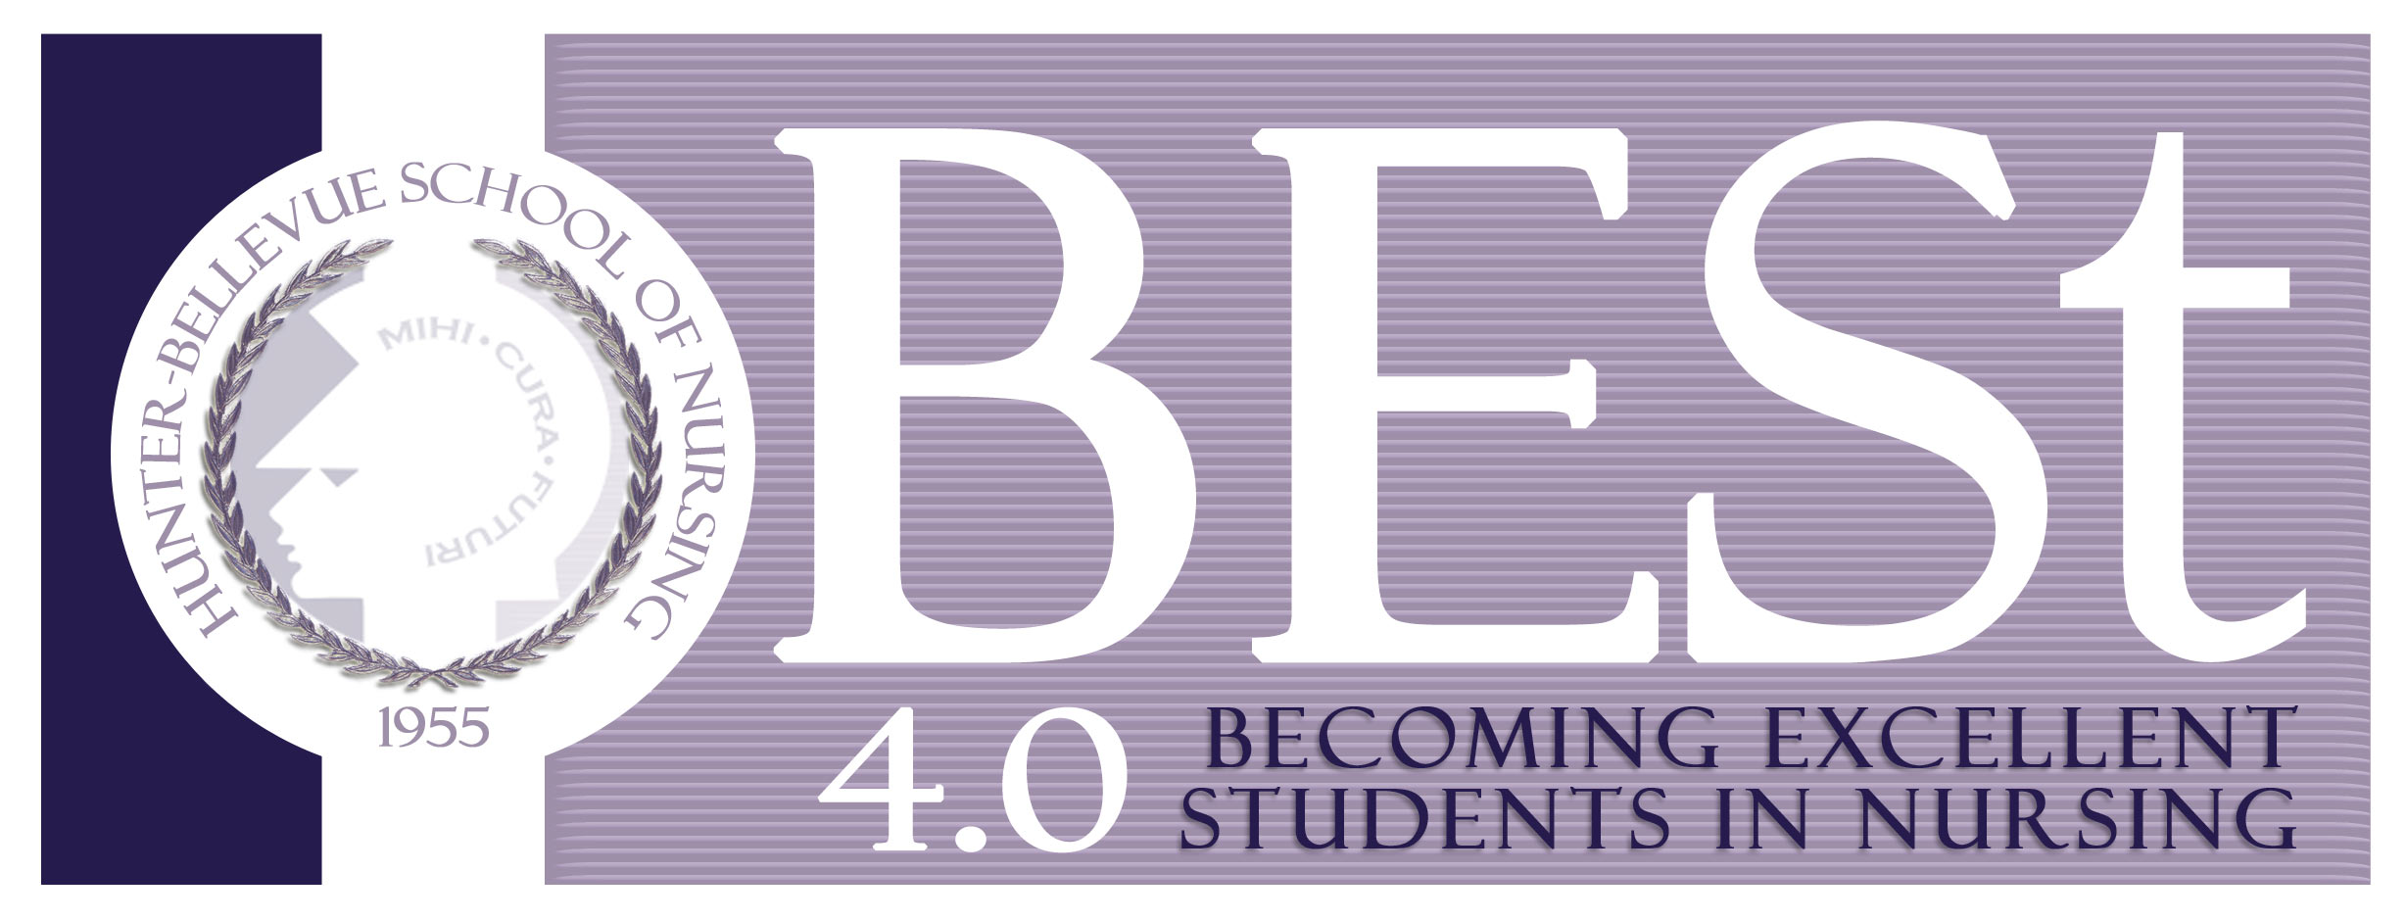
The BESt 4.0 Program provides academic enhancement activities to facilitate students’ success in transition to nursing.
The program offers:
NLN PAX Preparatory Courses
Professional Mentoring
Career Counseling in Nursing/Health Professions
Need Based Financial Assistance
Resume/Cover Letter Writing and Interview Techniques
Workshops: Stress-Management, Time-Management, Study Skills,
and Test Preparation
The BESt 4.0 Program is designed to increase diversity in the nursing workforce by providing services to enhance academic achievement and enrollment of individuals from under-represented groups (including minority students) into nursing programs. The project targets high school and college students who are interested in nursing as a career and those already accepted into the nursing major.

Jesse Lisnow
BESt 4.0 Program Coordinator
Hunter-Bellevue School of Nursing
Brookdale Campus
425 East 25th Street
(212) 481-6380 jlisnow@hunter.cuny.edu
http://www.hunter.cuny.edu/nursing/current-students/student-support/best-2.0
Supported by a grant from the Health Resources and Service Administration (HRSA), Division of Nursing
Becoming Excellent Students in Nursing (BESt 4.0)

Eligibility Requirements
for Manhattan Hunter Science High School (MHSHS) students

In order to be eligible for funding through the BESt 4.0 program, you must meet the following criteria:

- Be a U.S. Citizen or Permanent Resident Alien
- Be a student in good standing at the MHSHS
- Minimum GPA of B in the sciences
- Demonstrate a keen interest in the health sciences and health service professions
- Meet the definition of individuals from the following:

- Educationally or economically disadvantaged

- Under-represented minority groups including Black/African American and
Hispanic/ Latino

!!! IMPORTANT !!!
Please fill out the application and save it as a Word document. Attach the application to an email and send it to Jesse Lisnow at jlisnow@hunter.cuny.edu
Make the subject of the email "BESt Application".
Thank You !
BESt 4.0

BESt 4.0 Program Application (MHSHS)

Name: |  |  | DOB: |  | Cell Phone:  Home Phone:
Hunter College Email: |  | Home Address:
GPA: | # of Credits Completed: |  |  | Years at MHSHS:  Present grade level at MHSHS:
Name & Location of High School:
Social Security Number:
Current School Name:

(Check one)

Are you a U.S. Citizen?
Yes No If no, indicate what type of Visa:
Permanent Resident Alien Student Visa
Science classes:
Which science or health science classes have you completed?
Class: Grade:

Which health science classes do you plan to take?
Class: When:

Please indicate which ethnic group/s you identify with:
Pg. 246 of “Performance Report for Grants and Cooperative Agreements”
Ethnicity refers to two categories: “Hispanic or Latino” and “Non-Hispanic and Non-Latino.” “Hispanic or Latino” refers to an individual of Cuban, Mexican, Puerto Rican, South or Central American, or other Spanish culture or origin, regardless of race.

Hispanic or Latino

Non-Hispanic and Non-Latino
Specify country of birth:
(Check one)
Have you ever applied to the BEST Program before?
Yes No
If yes, when?

Have you ever been part of the BEST Program before?
Yes No
If yes, for what semesters?

Have you attended MHSHS since Freshmen year?
Yes No/Transferred from:

Do you live:
With parent(s) Other – please specify

Do you work:
Part-Time (Hours Per Week: ) Full-Time (Hours Per Week: ) Neither
If so, what type of work and where?

Will you have time available to participate in the workshops, tutoring, counseling sessions,
mentoring, and lectures that the BESt 4.0 Program will provide?
Yes No

What are your strengths? _______________________________________________________________________________________________________________________________________________________________________________________________________________________________
What are your major sources of stress? _______________________________________________________________________________________________________________________________________________________________________________________________________________________________

Student’s Signature: Date:

Voluntary Self-Identification

Pg. 251 of “Performance Report for Grants and Cooperative Agreements”

Race according to standards for the classification of federal data on race and ethnicity from OMB, five minimum categories on race exist: American Indian or Alaska Native, Asian, Black or African-American, Native Hawaiian or Other Pacific Islander, and White. The minimum categories for data on race and ethnicity for Federal statistics, program administrative reporting, and civil rights compliance reporting are defined as follows:

Please indicate with which of the following groups you would identify yourself:

American Indian or Alaska Native. A person having origins in any of the original peoples of North and South America (including Central America), and who maintains tribal affiliation or community attachment.

Asian. A person having origins in any of the original peoples of the Far East, Southeast Asia, or the Indian subcontinent, including Cambodia, China, India, Japan, Korea, Malaysia, Pakistan, the Philippine Islands, Thailand, and Vietnam.
Please Specify Country:________________________________________________

Black or African-American. A person having origins in any of the Black racial groups of Africa. Terms such as “Haitian” or “Negro” can be used in addition to “Black or African-American.”

Native Hawaiian or Other Pacific Islander. A person having origins in any of the original peoples of Hawaii, Guam, Samoa, or other Pacific Islands.

White. A person having origins in any of the original peoples of Europe, the Middle East, or North Africa.

Other (Please specify):_________________________________________________

The provision of this information is on a strictly voluntary basis.
If you prefer not to answer, please check here indicating that fact:

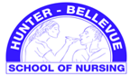

Fall 2013/Spring 2014

Dear Parent/Guardian:

Your child in the Manhattan Hunter Science High School is considering the opportunity to participate in the Becoming Excellent Students in Nursing Program (BESt 4.0). The purpose of BESt 4.0 is to facilitate the transition of a select group of MHSHS students into and through Hunter Bellevue School of Nursing (HBSON) to careers as baccalaureate– prepared nurses in service to NYC’s neediest communities. BESt 4.0 helps to increase nursing education opportunities for African American and Hispanic students by providing successful programs that will prepare our future nurses.
BESt 4.0 will start at the beginning of the new school year and run for a minimum of 8 weeks. Students will participate in an array educational and preparatory courses in the classroom and online to prepare them for college success. The courses emphasize college level science, readiness for professional development, and fundamental skills needed for a college environment.
If you would like your child to be a part of this tremendous opportunity, please fill out the forms and return forms to Holly Harrison, the Hunter College-MHSHS liaison.
Sincerely,

Jesse Lisnow
BESt 4.0 Project Coordinator
425 East 25th Street, Room 400W
jlisnow@hunter.cuny.edu
Hunter-Bellevue School of Nursing
(212) 481-6380

I give my son/daughter___________________________________ permission to participate in the Hunter Bellevue School of Nursing BESt 2.0 in Nursing program.

Parent/Guardian Name:____________________________________________________

Parent/Guardian Signature:__________________________________________________

Weekly Schedule

(Use the space below to indicate any days in the future when you will be available)
 | SUN | MON | TUES | WED | THURS | FRI | SAT
9am
10am
11am
12am
1pm
2pm
3pm
4pm
5pm

ESSAY:
DESCRIBE BELOW WHY YOU WOULD LIKE TO BE APART OF THE BESt 4.0 PROGRAM.
(MINIMUM 150 WORDS)

