Introductory Physics Hunter College
Rotation
Prelab
- Fill the table below with those equivalent physical variables for Rotational Motion.
Linear Motion  Physical Variables | Rotational Motion  Physical Variables Units
Displacement
Velocity
Acceleration
Force
Mass

- How many degrees are there in 0.5 radians? Show your calculation.
- What is the formula for Angular Momentum? What is the Unit?

Part I: Rotation
Procedure
https://phet.colorado.edu/sims/cheerpj/rotation/latest/rotation.html?simulation=rotation
1, Open the simulation and click on ‘Rotation’ tab.
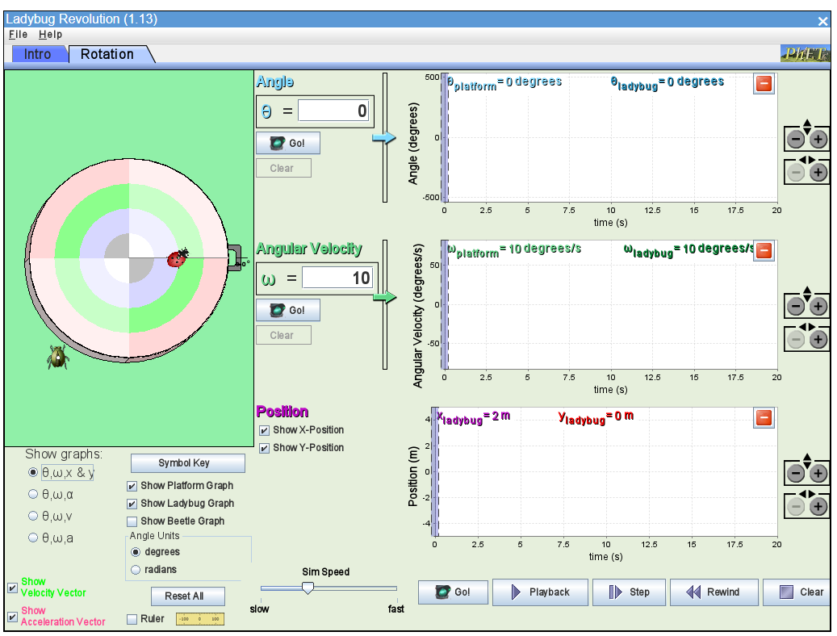1. Setup
Angle Units: degrees
Set Angular Velocity: 10
Show graphs: θ, ω, x, y
Adjust the scaling settings on the right side to make sure the data will be displayed properly on your screen.
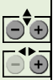
2.At time 0
- Record θ, ω, x, y in the data table.
- Switching the graph to get the values for angular acceleration α, velocity v, and linear acceleration a.
- Calculate the radius r from x and y.
- Calculate the v²/r

3. Reset the graph to θ, ω, x, y and click on the Go!
4. Click on the Stop after 5 s, take screenshot of your screen and complete the data table below.
5. Click on the clear button. Drag the ladybug to the position x=4 m and y=0 m. Repeat step 1 to 4.

Data
Table 1
Make sure to put units into the table.
Time | Θ degrees | Ω  degrees/s | X  m | Y  m | α | v | a | r | v²/r
0s | 0 | 10 | 2 | 0
5s |  | 10
0s | 0 | 10 | 4 | 0
5s |  | 10

Analysis
- From the screenshot, explain the x and y positions. What are mathematic functions can be used to describe those?
- Why is angular acceleration zero? Why the linear acceleration is not zero?
- When you change the position of ladybug, which variable are changed and why?
- What are the directions of linear acceleration and the linear velocity?
- What are the angular velocities in radians? Calculate the angles in radians (at 5 seconds) from the angular velocities.
- Set the angle to 5.0 rad and the angular acceleration to zero. Set the angular velocity to 3.5 rad/s. Predict the angle at which the ladybug will be at after 5 s. Check your prediction with the simulation. Was it correct?
- If the ladybug is on the 4m rim, use the simulation to find the minimum angular velocity that the ladybug will fly off the wheel? Calculate the maximum static friction coefficient between the bug and wheel?

Part II: Moment of Inertia
Procedure
https://phet.colorado.edu/sims/cheerpj/rotation/latest/rotation.html?simulation=torque
- Open the simulation and click on ‘Moment of Inertia’ tab.
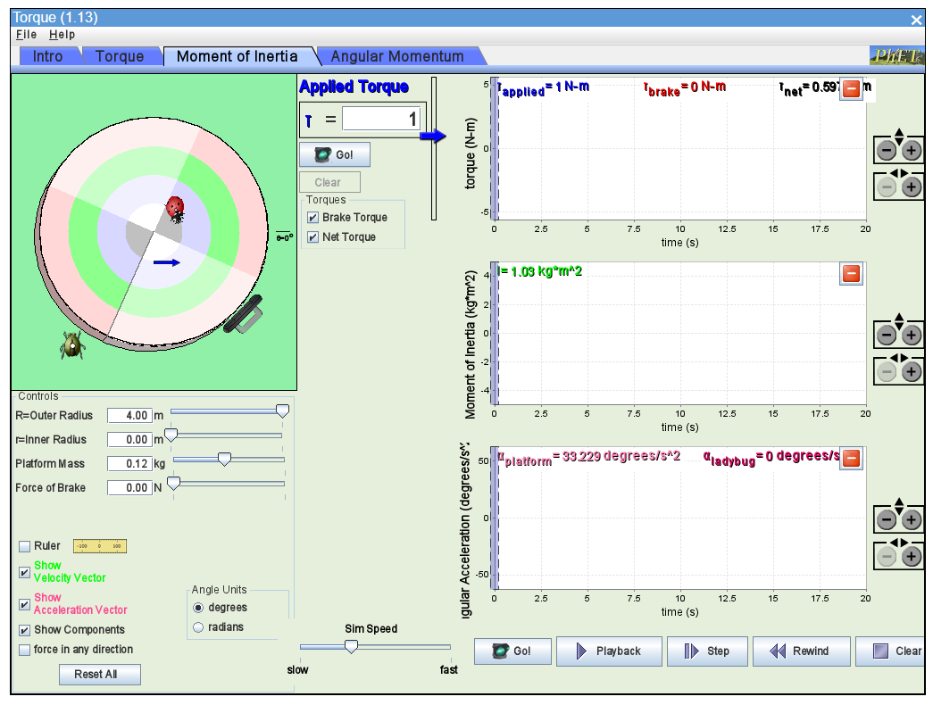
- Set the torque to 1 N. Change only one variable each time from the Base trial.
- Adjust the scaling settings on the right side to make sure the data will be displayed properly on your screen.
- Click on Go and run for 2.5 seconds and stop the simulation.
- Generate screenshots and record the data for the table below.
Data
Table 2
Make sure to put units into the table.
Trial | Torque | Mass | Radius (inner) | Radius (outer) | Angular acceleration (α) | Moment of Inertia (I) | Change of I from Base Trial | Change of α from Base Trial
Base trial | 1 N | 0.12 kg | 0m | 4 m
Increase Mass
Increase Inner Radius
Decrease Outer Radius
Increase Torque

Analysis
From the screenshots and table above, explain the following:
- How does mass affect moment of inertia? and why?
- How does mass distribution affect moment of inertia? and why?
- When you increase the Torque, what kinds of effects do you observe? Explain why?
Part III: Angular Momentum
Procedure
- Open the simulation and click on ‘Angular Momentum’ tab.
- Set the Angular velocity to 20 degrees/s.

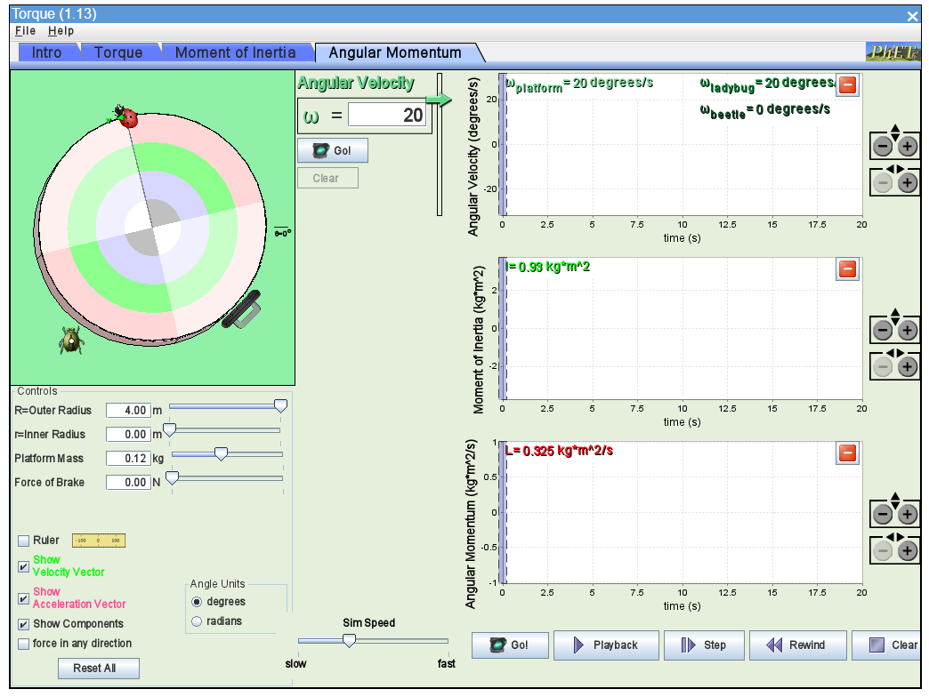
- Drag the Inner Radius from 0 to 4 m and take screenshot at the end.
- You should see some changes in angular velocity and Moment of Inertia. If it is not, adjust the scaling on the right to show the data on the screen.

Analysis
      - What is the SI unit for angular momentum?
      - Calculate the angular momentum in SI units?
      - Explain why the Angular Velocity changes.
      - Does Angular Momentum change? Why?
Post-Lab
1.The diagram shows a top view of a child of mass M on a circular platform of mass 5M that is rotating counterclockwise. Assume the platform rotates without friction. Which of the following describes an action by the child that will result in an increase in the total angular momentum of the child-platform system?
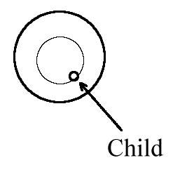
(A) The child moves toward the center of the platform.
(B) The child moves away from the center of the platform.
(C) The child moves along a circle concentric with the platform (thin line shown) opposite the direction of the platform's rotation.
(D) None of the actions described will change the total angular momentum of the child-platform system.

2. A solid disk with a mass of 1.0 kg and a radius of 0.25 spins at an angular velocity of 10 rad/s. A string that wraps around the edge of the disk applies a 2.0 N force tangent to the disk, for 0.5 seconds. What is
the new angular velocity?

