 | Hunter College P.T. Alumni Newsletter
Vol. 4 No. 1  Fall, 2007 | A publication of the Physical Therapy Program, School of Health Sciences, Hunter College
From a BS degree to a MPT and now a DPT,
our curriculum is constantly evolving!

Visit and subscribe to one of our web sites:
www.hunter.cuny.edu/schoolhp/pt
You can subscribe to our PT Internet List Serve, which can be used by alumni, students and faculty to issue announcements, communicate with each other, plan meetings, etc. To subscribe (no charge), send an email to: majordomo
@.hunter.cuny.edu In the message section, type exactly: subscribe pt-l (l is the letter L). You can send a posting to all members of the mailing list by sending email to: pt-l@hunter.cuny.edu

Programmatic Activities:

We enrolled our first class of students in our DPT program in the summer of 2006. This DPT program is in collaboration with the Graduate Center of CUNY, which is the only CUNY institution that issues doctoral degrees. This new curriculum replaces our MPT curriculum that started in the Fall of 2000. Our last MPT class will graduate in May, 2008. All DPT students enter the program with a bachelor’s degree in any major. The curriculum is three years long, including summers. This is a very significant change from any bachelor’s degree program. The greatest change from our MPT curriculum is a research requirement (students must work in small groups and carryout clinical research), expanded cardiopulmonary content, clinical decision making, differential diagnosis and an integumentary course. Our MPT curriculum was designed to be equivalent to many DPT programs, so when we transitioned to the DPT, we only enhanced the curriculum. Graduates of our MPT curriculum should expect to have some of the courses applied toward any post professional DPT program.
Hunter College P.T. Program Alumni Newsletter
To contact the P.T. Alumni Association, send all correspondence to:
Hunter College P.T. Alumni Association, c/o P. T. Program, 425 East 25th Street, NY, NY 10010
Editor: Dr. Krasilovsky
email: gkrasilo@hunter.cuny.edu

If you would like to read more about our DPT curriculum, please go to our website. If you know someone who is applying, recommend to them that they come in for one of our informational sessions. The dates are posted under News and Events on our website.

Research Collaboration with the Hospital for Special Surgery and NYU Medical Center

Many of you remember walking or taking the bus up to the Hospital for Special Surgery for our Orthopedics course. Our students still continue to travel there for our two orthopedics courses, but we also have established a research collaboration with the Department of Rehabilitation Medicine. Our students and faculty will be working with the physical therapy and rehabilitation staff at HSS on collaborative, clinical research projects. This will allow support for clinicians to collect, analyze, and publish clinical research, and use this information to make clinical decisions about PT practice. Our students and faculty will be participating in these projects, exposing students to meaningful research endeavors and eventual publication of the manuscripts. We have also established a similar research collaboration with New York University Medical Center. We expect to and are interested in expanding these research collaborations with other institutions. These are win-win collaborations for our students, faculty, the institution and the profession by facilitating clinical research at patient care centers. Our DPT students and research mentors at the facilities are the key components of these collaborations.

Post-Professional DPT:
We will not be offering our own post-professional DPT curriculum for alumni. We were being told to include requirements that would have exceeded what we consider necessary and reasonable to upgrade our MPT graduates. Those of you interested in earning this higher degree and updating your education have probably already pursued other available programs. In order to assist our alumni in this process, Dr. Krasilovsky has established letters of agreement with some of these post-graduate programs. They have reviewed our MPT curriculum and determined that some courses you completed in your entry level program at Hunter College were equivalent to a course in their t-DPT (or post-professional DPT) program. As of February, 2007, agreements have been finalized with SUNY Stonybrook and Des Moines University (an online program). More details on the programs that have completed these reviews and the courses they are waiving are posted on our website (click on the alumni page).

Faculty & Staff Updates:

The faculty, individually and collaboratively, have been very active in teaching, research, publishing, service to the College and the profession. The faculty have been very successful in producing peer reviewed publications. A listing of these accomplishments is on page three. All faculty are members of the American Physical Therapy Association.

Suzanne R. Babyar Rothbart, PT, PhD has been with the Physical Therapy Program since 1992. She completed her doctorate in Physical Therapy Clinical Research from New York University at that time. Her teaching has focused on two areas: neurological evaluation and intervention for the adult patient and joint examination and treatment. In 2004, the New York Physical Therapy Association awarded her the Outstanding Service to Chapter for her work with the Research Committee. She enjoyed a sabbatical at Burke Rehabilitation Hospital (White Plains, NY) where she developed investigations relating to “pusher syndrome’ or lateropulsion following stroke. She continues to collaborate with the therapists on the Stroke Unit and with its Director, Michael Reding, MD. With the help of release time from teaching during the 2005-2006 academic year, she was able to complete two studies with this population and start another one with patients with unilateral neglect following stroke. She presented one of the studies as a poster at the International Stroke Conference, American Heart Association, in San Francisco, CA in early February 2007. Her second line of research is in the development of clinical reasoning by physical therapy students. With Dr. Elaine Rosen and Dr. Susan Pivko, she is currently conducting a national on-line survey of students who are nearing completion of their final clinical education experiences. This area of study will also be developed by a DPT student as her research project. Another group of DPT students are working with Dr. Babyar and Rob Maschi and Theresa Chiaia at the Hospital for Special Surgery as they develop a tool for measuring functional milestones after anterior cruciate ligament repair. She sits on the Executive Committee for the Clinical Doctoral Programs at the Graduate Center of City University of New York and is a member of the School of Health Sciences Personnel and Budget Committee. She chairs the School of Health Science Honors and Awards Committee. Dr. Babyar holds membership with the American Society of Neurorehabilitation and the American Heart Association.

Tom Holland, PT, Ph.D has been a full time faculty member since 1994. He is the Recipient of the Hunter College 2003 President's Excellence in Teaching Award. Tom has been a physical therapist for 26 years and a full time educator for 21 years. Dr. Holland completed his doctoral studies at New York University with research related to neuromuscular changes following stroke. His areas of teaching and clinical expertise include: prosthetics and orthotics, wound care / prevention, adult rehabilitation, and physical modality use for rehabilitation. Dr. Holland has served as an adjunct instructor at Columbia University, N.Y.U., Touro College, and SUNY Brooklyn. In addition to teaching, he continues to maintain clinical practice at Kessler Institute of Rehabilitation in Saddle Brook NJ. Tom resides in West Nyack NY with his wife and four children.

George Ibrahim, DPT joined our faculty in 2005 but has resigned after this academic year. He will continue as an adjunct teaching our pediatrics course. Dr. Ibrahim has a strong clinical background working with a pediatrics population. He was teaching all pediatric curriculum content and was also developing a role as co-director of clinical education. We will be searching for a replacement faculty member in the Fall of 2007.

Gary Krasilovsky, PT, Ph.D. joined the faculty in 1987 and has been serving as Program Director since the retirement of Dr. Ayers in 1989. He has developed and coordinated the many curriculum revisions that have evolved into the DPT program. Dr. Krasilovsky has also written and coordinated the ongoing re-accreditation of the PT program, including many self-study reports and on-site visits. The program recently received full accreditation through 2016. Dr. Krasilovsky has been involved in Committee work in all levels of the college, including the Master Planning Committee and Strategic Planning Committee of Hunter College. He also now serves as Director of the DPT and MPT program, which includes serving on the Executive Committee for the Clinical Doctoral Programs at the Graduate Center of City University of New York. In 1999, he coordinated total physical renovation of the Physical Therapy area, including new central HVAC, offices, classrooms, and laboratories. He has also recently authored or co-authored chapters in two textbooks listed under faculty publications, and served as contributing editor, with Dr. Holland, for a major revision of the Physical Agents textbook.

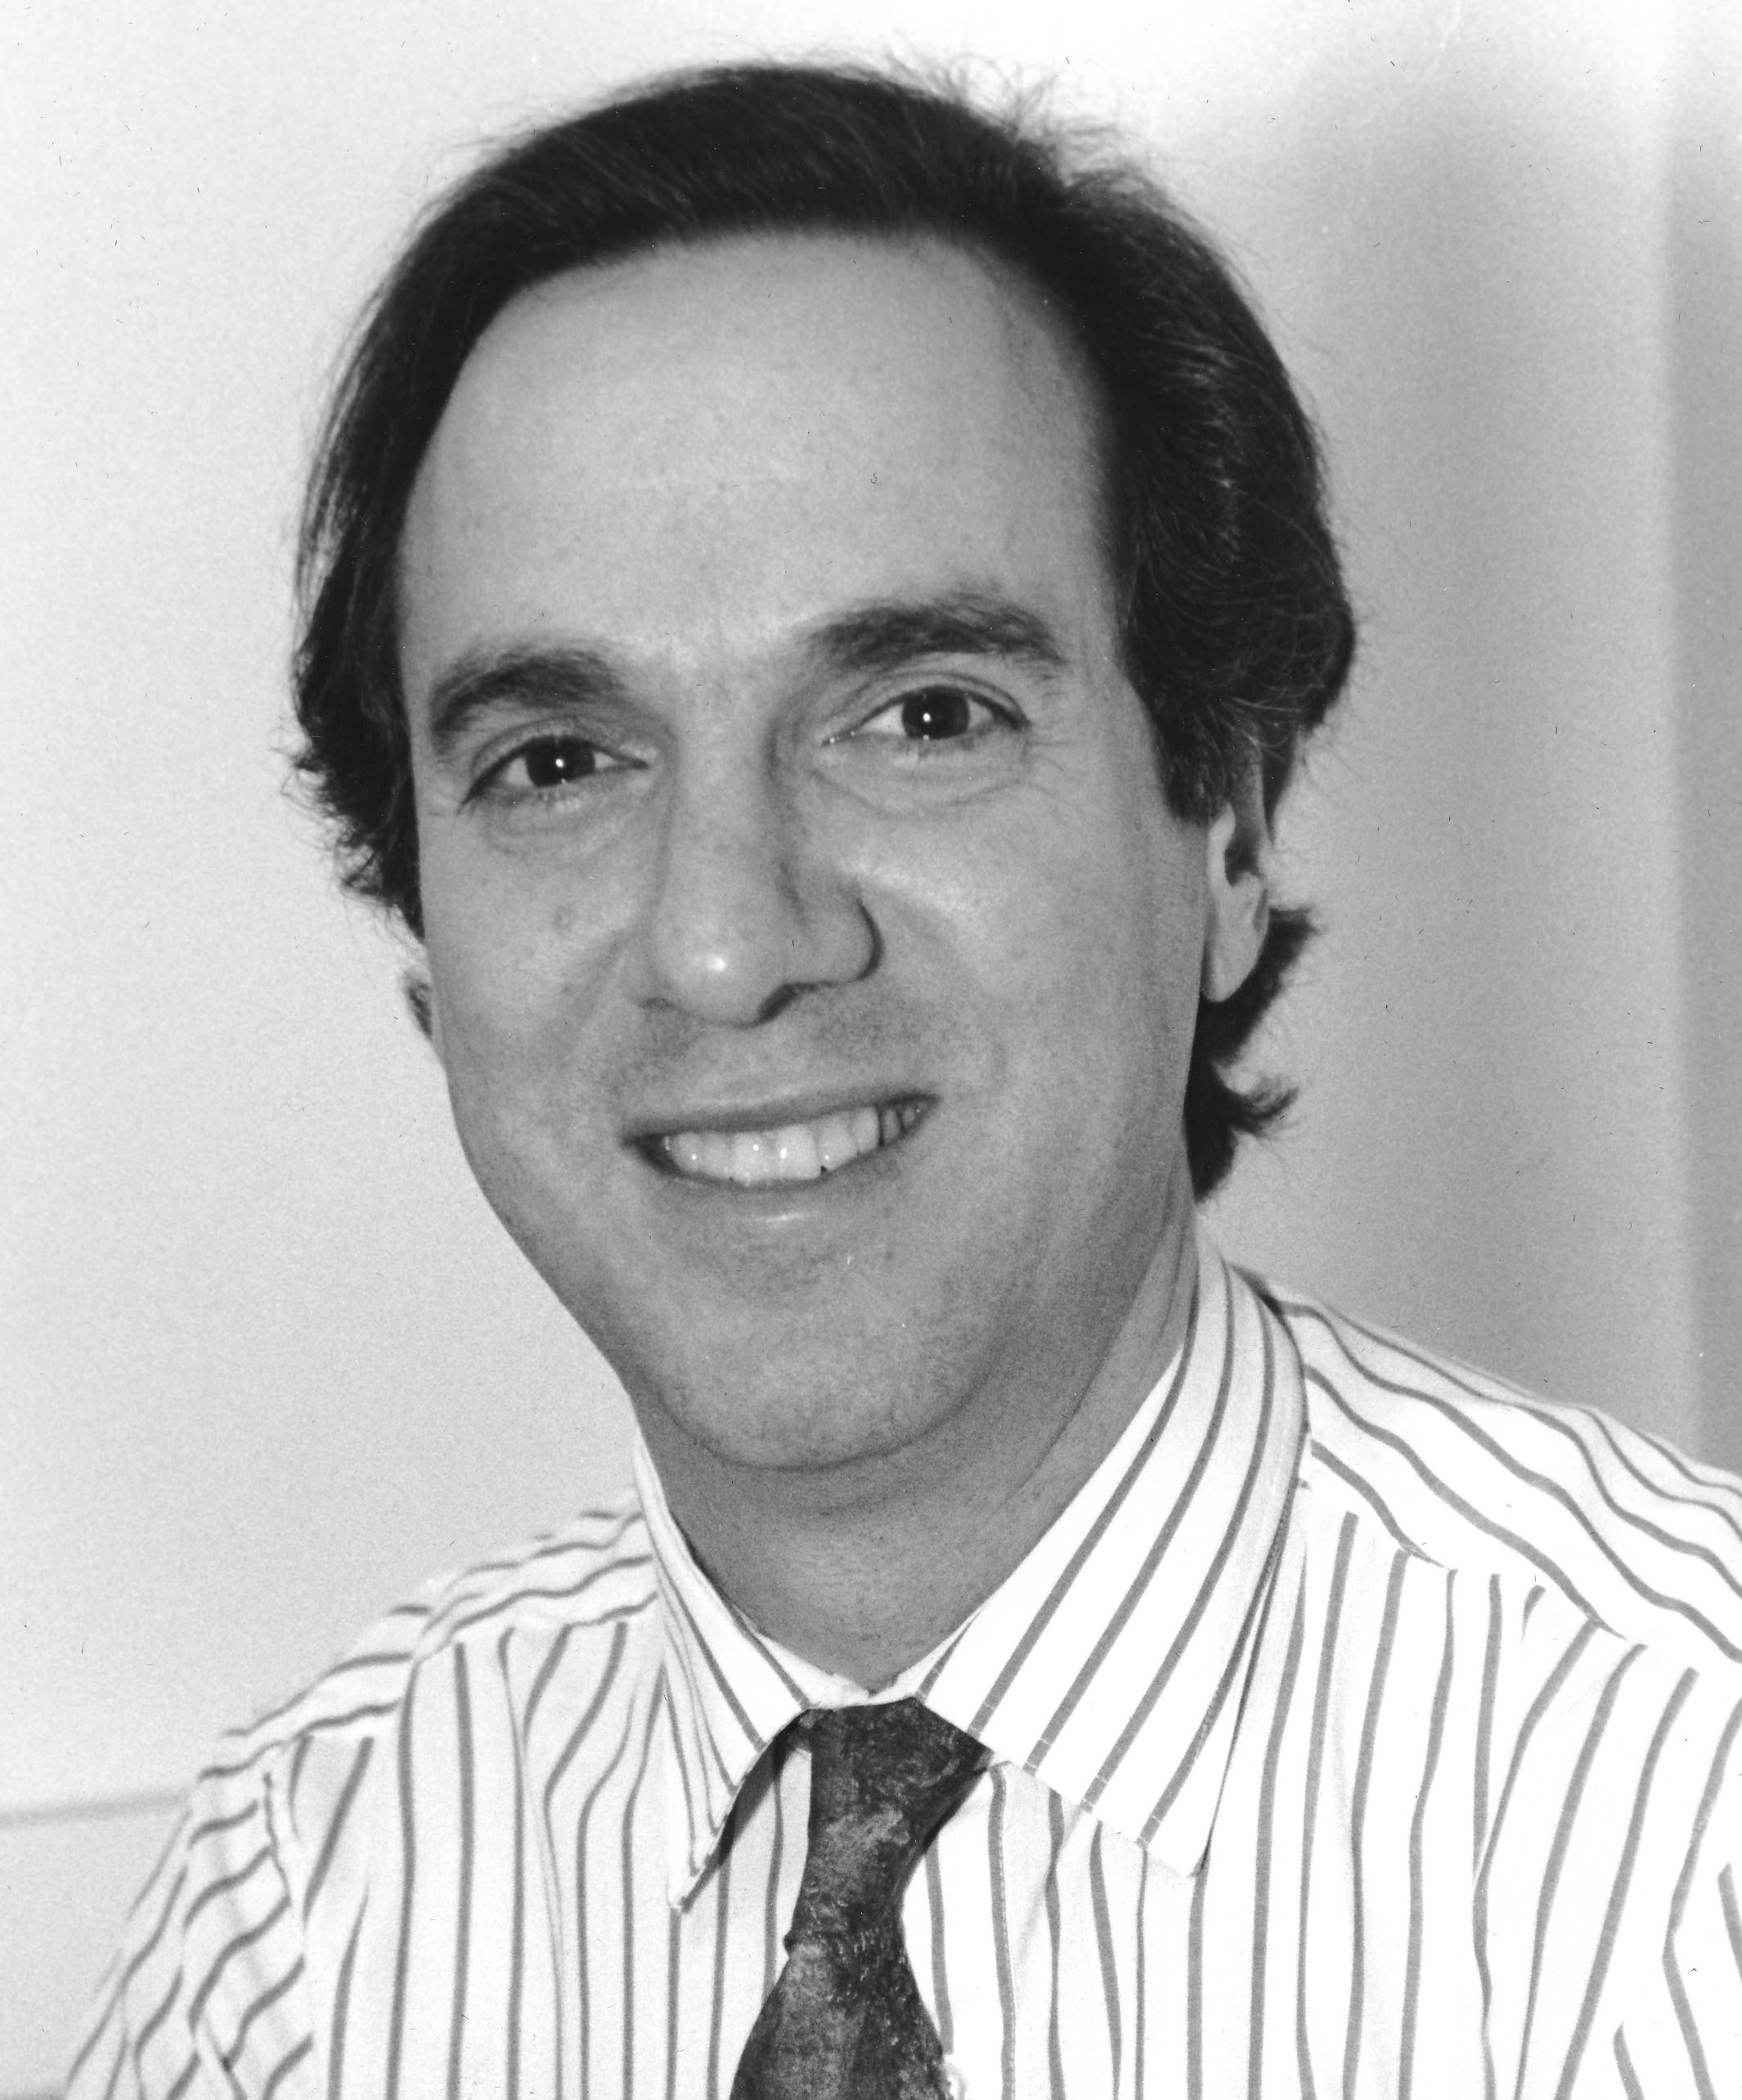

Milo Lipovac, MD, Ph.D. joined our faculty in 1999. Dr. Lipovac has many years of teaching experience including prior years in PT education and research. He is taking a sabbatical this coming year and will be working on a wound care textbook with his wife, Dr. Stanajka Lipovac, who is an MD, PT and Certified Wound Care Specialist. She also teaches as an adjunct in our program.

Elaine Rosen, PT, DHs, OCS earned her DHs at the University of St. Augustine, Florida. She recently earned recertification as an OCS. Recipient of the (Orthopedic Section, APTA) 2003 James A. Gould Excellence in Teaching Orthopedic Physical Therapy Award Dr. Rosen recently served as co-editor for a new textbook based on the Guide to PT Practice. Her textbook Musculoskeletal Examination has been translated as follows: Czech (2006), Italian (1999, 2002), Japanese (1998, 2002), Portuguese (2000, 2005), simple Character Chinese (2003), Korean (1996) for international distribution. It is presently being translated into Spanish.

Susan Pivko, PT, DPT joined our faculty in 2004 as Assistant Professor and our Director of Clinical Education. A graduate of the PT program at McGill University in Montreal, Quebec, Canada, she completed her Doctorate of Clinical Physical Therapy from the University of Medicine and Dentistry of NJ in 2002. She has many years experience in rehabilitation in NJ and internationally and continues to practice with PT specialties of Spine, Elite Athletes and Performing Arts, her personal areas of interest. Dr Pivko has been the Research Coordinator for our new research partnerships with HSS and NYU and has also presented her own research at all the national and international PT conferences during the academic year of 2006 and 2007. She continues to develop scholarship in topics of clinical education and clinical practice.

As a member of the Senate Budget committee, Dr Pivko is actively involved in the university environment and has also served on search committees for faculty and Associate Dean. She is currently involved in the development of the Hunter College Clinical Educator Incentives program to recognize the extraordinary contributions of our affiliate institutions.

Mary Cleary, Office Assistant - I have been with the Physical Therapy program since October 2001, and I'm so lucky to have found a job that I enjoy. I have met so many wonderful people and know if I ever need physical therapy, I have a host of people to call. I wish everyone the best in both your professional and personal life.

Faculty Publications:

Babyar SR, Rosen E, Macht Sliwinski M, Krasilovsky G, Holland T, and Lipovac M. 2003. Physical Therapy Student’s Self-Reports of Development of Clinical Reasoning: A Preliminary Study. Journal of Allied Health, 32:227-239.

Babyar SR, Hildebrand McCloskey K, Reding M. (2007). Surface Electromyography of Lumbar Paraspinal Muscles During Seated Passive Tilting of Patients with Lateropulsion Following Stroke. Neurorehabilitation and Neural Repair. 21: 127-136.

Babyar SR and Krasilovsky G. Musculoskeletal Pattern 4C: Muscle Performance. In: Moffat, M, Rosen, E, Rusnak-Smith SE (2006) Musculoskeletal Essentials: Applying the Physical Therapists Preferred Practice Patterns, Thorofare: NJ, Slack Publishers.

Holland T. (2006) Instructors Manual: Integrating Physical Agents in Rehabilitation. Upper Saddle River, NJ: Prentice Hall.

King, L, Rosen, ER, Rusnak Smith SE (2006). Practice Pattern F: Spinal Disorders in Rosen ER, Rusnak Smith SE. Musculoskeletal Essentials: Preferred Physical Therapy Practice Patterns, Slack Publishers.

Krasilovsky G. (2006) Biofeedback. In: Hecox B, Weisberg J, and Mehreteab T. Eds. Krasilovsky G and Holland T. Contributing eds. Physical Agents, 2nd Ed., Upper Saddle River, NJ: Prentice Hall.

Lipovac MN, Holland T, et al. (2003). The possible role of glutamic acid uptake in metaphit-induced seizures. Neurochemical Research 28:723-731.

Lipovac, M.N., Reith, M.E.A., and Lajtha, A. (2006) Metaphit induced seizures and transport of GABA across the blood-brain barrier. Neurochemistry International

Mehreteab TA, Holland T. (2006) Effect of electrical stimulation on nerve and muscle. In: Hecox B, Mehreteab TA, Weisberg J, Sanko J, eds. Integrating Physical Agents in Rehabilitation. 2nd edition Upper Saddle River, NJ: Prentice Hall.

Mehreteab TA, Holland T. (2006) Iontophoresis. In: Hecox B, Mehreteab TA, Weisberg J, Sanko J, eds. Integrating Physical Agents in Rehabilitation. 2nd edition Upper Saddle River, NJ: Prentice Hall.

Mehreteab TA, Holland T. (2006) Clinical uses of electrical stimulation. In: Hecox B, Mehreteab TA, Weisberg J, Sanko J, eds. Integrating Physical Agents in Rehabilitation. 2nd edition Upper Saddle River, NJ: Prentice Hall.

Mehreteab TA, Holland T. (2006) Therapeutic electricity. In: Hecox B, Mehreteab TA, Weisberg J, Sanko J, eds. Integrating Physical Agents in Rehabilitation. 2nd edition Upper Saddle River, NJ: Prentice Hall .

Rosen, ER, Rusnak Smith SE. Practice Pattern B, Impaired Posture In Moffat, M, Rosen, E, Rusnak-Smith SE (2006) Musculoskeletal Essentials: Applying the Physical Therapists Preferred Practice Patterns, Thorofare: NJ, Slack Publishers

Sziraki I, Hashim A, Sershen H, Allen D, Cooper T, Lipovac M, and Lajtha A. Strain differences in sensitivity of central dopamine systems to nicotine in Lewis and Fischer 344 rats. In Monitoring Molecules In Neuroscience, Eds: Jan Kehr, Kjell Fuxe, Urban Ungerstedt, Torgny Svensson. Karolinska Institute, Stockholm Sweden, Proceedings of the 10th International Conference on In Vivo Methods, 143-145, 2003.

Published Abstracts and Presentations
Abstracts:
Babyar SR, Reding M. (2005). Effect of Lateropulsion on Stroke Rehabilitation Outcome. Neurorehabilitation and Neural Repair. 19:380.

Moore E, Feld J, Babyar SR, Jordan B. (2005). Relationship of the Berg Balance Scale Items and Outcomes for Individuals with Acquired Brain Injury in an Acute Rehabilitation Setting. Neurorehabilitation and Neural Repair. 19:378.

Presentations:
Pivko, S., Silberman, N., DeMasi, I., Taylor, M., Jain, A. The Prerequisites,
Performance and Perceptions of the ACCE/DCE in Emerging DPT Programs
- National Education Leadership Workshop, Washington, DC, Oct, 2006
- APTA Combined Sections Conference, Boston, MA, Feb 2007
- World Physical Therapy Conference, Vancouver, BC Canada, June, 2007
- American Physical Therapy Association Annual Conference, Denver, Colorado, June, 2007.

Recker-Hughes, C., Pivko, S., Mowder-Tinney, J.J .,Brookes, G. (2007) Clinical Instructors’ self-perceptions of competence in teaching core content areas of curriculum to professional DPT students: Implications for academic
programs.
- World Physical Therapy Conference, Vancouver, BC Canada, June, 2007.

Babyar, S.R., White, H., Shafi N., Reding, M. (2007, Stroke). FIM™ Efficiency Lower in Patients with Stroke and Lateropulsion: A Case-Matched Controlled Study.
- International Stroke Conference. San Francisco, CA. February 7-9, 2007.

P. T. Adjunct Faculty

We would like to acknowledge the participation of our adjunct faculty who have continued to make significant contributions to our Program:

Rima Badawi, R.Ph.
Bobby Belarmino, PT, MA
Karen Bergsman, PsyD
Marc Campo PT, MS, OCS
Elizabeth Dominick, DPT, PT, NCS
Amy Drum, MPT
Greg Gao, MD, PT
Rosalinda Guce, MD
Laura Gutman, PsyD.
Amy Hess, MS, PT
Diane Holland, PT, CWCS
Michael Ingino, PT
Karilyn Hildebrand, PT
Barbara Karpinska, PT
Kristine Kinsley, PsyD
Stanajka Lipovac, MD, PT
Martha Macht Sliwinski, PhD, PT
Jeme Mosca, MBA, PT
Keith Peterson, MPT
Sandy Rusknak Smith, PT, OCS
Teresa Smith, MS, PT, NCS
Department Renovations
The lower level of the East building was totally renovated during the summer of 1998. This includes modern heating, lighting, air conditioning, new walls and floors. A new P. T. classroom and two additional faculty offices have also been constructed. This completes the modernization of the classroom and office equipment and establishment of a motion analysis laboratory. We now have a very modern teaching and research environment for students and faculty. Due to significantly improved financial support, we also have state-of -the-art technology for teaching and modernized labs.

New Health and Science Building:
Recently, plans have begun to materialize for a new Health Professions and Science building two blocks away from the main campus. All Brookdale based programs would eventually move into a new building that is presently in the planning stages. The Brookdale campus houses other science labs and is physically constructed to prevent true modernization of most of its facilities. The Physical Therapy Program is proposing establishing an on-site clinical site in collaboration with the nursing faculty and the communication sciences program. Although our program space is one of the best in the Brookdale Campus, this new building will provide many excellent opportunities. We will be in walking distance to the main campus for collaborative activities with other programs, services will be more accessible, and we will also be in walking distance to the many hospitals and medical institutions on the upper east side of Manhattan.

Alumni Event – seeking class representatives

We would love to hold an alumni event to serve as a facilitator of each of you to reconnect with your classmates and network with other alumni. We are always seeking additional excellent clinical education sites for our students, and we know you have the foundation to have developed into an excellent clinician and mentor. If you would serve as a class coordinator to help reach out to your fellow classmates, please contact us! If you know other Hunter alumni, ask them if they received this newsletter and if not, have them contact us. You will have an opportunity to tour our new facilities and meet the faculty and other classmates.

If you are interested in speaking at high schools, colleges, or other organizations about physical therapy or about the Hunter College PT program, please contact us. We may be able to provide you with up-to-date information and we have physical therapy visual aids (such as videotapes, slides, brochures). We are especially interested in attracting students from under-represented groups. We need alumni assistance in this, especially mentors for future applicants.

George Valles Retires
George, our caretaker for many years, has retired this year. We gave him a retirement party, complete with gifts from the faculty and students. He was really touched by our display of wishing him well as he moves into his new lifestyle. We miss his friendly smile and competent service!

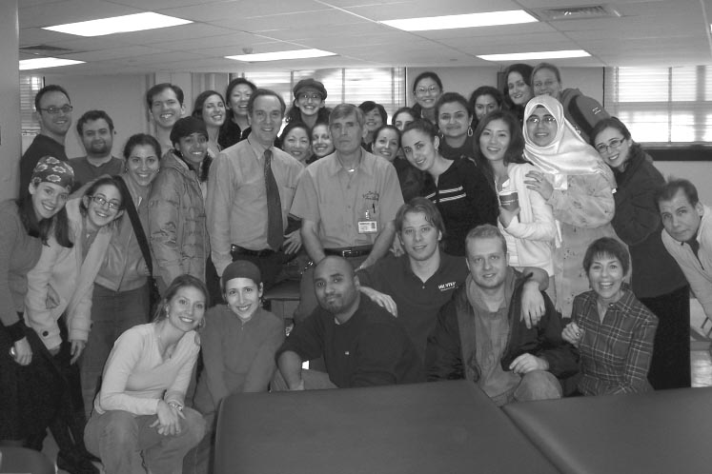
Recent Alumni News

An * before someone’s name indicates they have volunteered to serve as a class representative. Be a star!!

Kathleen Albany, prior treasurer of a Hunter College Physical Therapy Alumni Association, tracked down an account that had been dormant for over about fifteen years. The bank had been sold multiple times, but she persevered and obtained the funds plus interest. We now have an alumni account with over $6300 being monitored by Dr. Krasilovsky that is being held through the Hunter College Alumni Association. This account, coupled with funds generated by the PT program, will be used as seed money for an alumni event and/or to obtain additional research equipment. If you would like to donate to this account, this would be greatly appreciated. More information on donating to the PT Program is at the end of this newsletter.

Please let us know what you are doing professionally and/or personally. See it in print here in our next edition.

2000’s:
Andrew Megginson (2007) Currently, I am spending hours a day at home studying for my National Licensing Exam. I intend on taking it in mid to late July. I have a job waiting for me in outpatient orthopedics at West Side Dance Physical Therapy. They serve a population that is half professional dancers, and half general public. They especially work closely with the New York City Ballet, and the School of American Ballet at Lincoln Center. I’m very excited to be considered for this position as I have a lot to learn, and they have a lot to teach me. I am also working feverishly on planning my wedding to my fiancée, Andrea Johnston, which will occur on August 25, 2007, in Toronto, Ontario.

Shari Nadel (2007) I’m working as a staff PT at New York-Presbyterian/Weill Cornell Medical Center.

Karen Skolnik (2007) I just wanted to say hi and thanks again for being such a great program director. I wanted to let you know that I am working at an outpatient practice in Chelsea
(http://www.infinitysportsmedicine.com/) and i love it! There is another Hunter alumni there too. Her name is Inna and she graduated 3 years ago. I can tell she will be a great mentor and I look forward to learning so much more over the next few years. I am also studying for the boards (passed them!) and planning my wedding (next May I think), making this summer not so relaxing but very exciting! I hope everything is going well with you and the rest of the Hunter community.
Stephanie Tarasco (Mooney) 2007 Stephanie was married this August to Jim Mooney and is now being to look into jobs and study for the licensure exam.

Dan Roth (2006) Works at Roosevelt hospital (acute orthopedics) and at Advanced PT (out patient ortho, in the evenings. He is enrolled in a certification course with Stanley Paris.

James Campo (little Jimmy) (2006) He’s working at Mt. Sinai Hospital. Still not married (did you want some matching from us?) Still going on road trips with Dan and Shields (Binh abandoned us). Working towards Paris Certification with Dan Roth.

Hea-Jung Fico (2006) I’ll be starting my fourth job of 2007 in September, working as an independent contractor with Nassau BOCES. Emma (5) and Sara (2) are healthy and growing. Going for that tDPT. Really missing all of my classmates. Let’s all get together!

Orit (Pollak) Gross (2006). (917) 676-6766
As you all know I am married and have a beautiful daughter Rachelli who is now 18 months old. I am working in a center based pediatric facility that specializes in sensory integration and the developmentally delayed from ages 0-13 years old.
I love what I do very much and I find it very rewarding every single day. I can’t wait to hear from everyone else. Hope everyone is having a great summer. Keep in Touch!

Jim Newton (2006) I am here in sunny Vero Beach, Fl working in a wonderful clinic called The Spine and Sport Institute. All is well and the job is fantastic! We bought a house in June Come and visit - we are 5 blocks from the ocean and 1 block from the river.... Let the hurricanes come - I am ready for them! Hope everyone at Hunter is doing well. Can't say I miss the city but I sure do miss you guys. All the best.
Dara Saker (2006) Just a quick update on our life here in Passaic. We had our 4th child-another girl in October, her name is Neely Eliana. I sat for (and thankfully passed!) the exam in December, and I am currently working for Kipnis Physical Therapy and Sports Rehab in Cliffside Park, NJ. I hope everyone is well, I know a girl from Passaic started the the program this year (my cousin worked with her for Therapy Associates) Hope everyone is well, and please send my regards.

Jamie Bernal (2005) I just moved to New Mexico and have been working in Albuquerque for about a month. I am working for a hospital doing OP. Look forward to the newsletter.
Allison Cashen (2005) Working at NYU for 1 and 1/2 years. It’s a great place for a new graduate!! I recently got engaged in April!! Extremely happy with the job, I love it!! Thanks for everything!!

Jemina Cassis (2005) I am still married, living in the Inwood section of Manhattan with one sweet little monster who is 1 and a half. I work part time at west side dance PT and I love it.
By the way I am interested in helping out with future IPA courses at Hunter, please let me know!

Christina Cortez (2005)..or as of 10/8/2006, Christina Ronco !!! I hope all is well with everyone. Everything is OK with me. I got married in October and am currently working in Eastchester N.Y at Forme Rehabilitation. I have been here for 2 years (since graduation) It is an outpatient ortho clinic. I just had my first experience being a C.I. and it went really well.

Colleen GaNun (2005) This fall I am planning to leave Peninsula Hospital (where I have been working for 2 years in sub-acute, acute and now on the TBI unit) to do travel PT. At this point I am doing home care and working here, planning my sister's baby shower, and being a bridesmaid for two July weddings.

Greg Misch (2005) Hello to the entire PT faculty @ Hunter. Jack, Amy & myself are all currently working with Dr. Gross at Union Square Rehabilitation & Sports medicine. Everyone is doing fine and Jack will be traveling to Thailand for a couple of weeks to visit his brother. Hope all is well with you and best regards! Take care.

Natalia Rothey Glenn (2005) I got married in May of 2006 and now I have a 3 month old son, Alexander. I am living in Ridgefield, CT. After graduating from Hunter I worked for Premier Physical Therapy (where I had my last affiliation on E77th st) and then I was transferred to their Katonah office since my finance lived in Westchester. I worked for them for almost 2 years and then I stopped working a few months ago so that I could stay home with my baby. During the time that I was working I took 3 continuing ed courses all from IPA. I took FO1 and FO2 and BET.

Anna Barkov (2005) I’d like to announce the birth of Emily Sarah Barkov, born December 3, 2006. I’m currently on maternity leave, formerly employed at Coney Island Hospital.

Sarah Laufer (Bruckstein) (2005) I wanted to update you that I had a baby girl this past April and I am working at the Hebrew Home For the Aged at Riverdale. I am looking forward to hearing what everyone else in the class is up to!

Denise Bogusky (2004) Please tell everyone I said hi and wish everyone the best! Things are good with me. I am working at Positive Beginnings Pre-school with Kristen Lehenbauer and love it!

Penina (Einhorn) Kartaginer (2004) I am married with 2 little girls, and I work part time for BATA, an early intervention agency in Lakewood, NJ. Looking forward to seeing the newsletter! Thank you!
Jennifer Gallinaro (2004) Working at Sports PT at The Hospital for Joint Diseases. Currently enrolled in Touro College for my DPT with a specialization in Orthopedics.

Dahlia Farago Saperstein (2004) Married, with one son Samuel Aaron age 2 and expecting another in November, 2007. Worked at St. Mary’s Hospital for Children for over 2 years; now working at HASC (Hebrew Academy for Special Children…Preschool in Woodmere, NY) and doing some extra CPSE and EI cases as extras…loved the experience at the hospital but Preschool hours and vacations easier on my family…. Suggestion to classmates: take the courses offered by Mary Massery PT (If You Can’t Breathe, You Can’t Function, and Later, the Advanced Course follow up entitled Clinical Applications to Patient Scenarios). They are excellent!

Aija Paegle (2004) I am now living in Astoria and working at Integrative Care Center, Hospital for Special Surgery.

Keith Peterson (2004) I have been practicing, teaching, and thinking about transitioning to a DPT [and perhaps
a PhD]. I continue working for Pamela Paspa at Paspa Physical Therapy on West 35th Street in Manhattan. This is a terrific, private office with 5 therapists. We are members of the HSS Rehab network and are fortunate to receive referrals from HSS surgeons and physiatrists. Watch for our coming website at www.paspapt.com ! I’ve just finished my 2nd summer as a lab instructor in anatomy for Hunter’s DPT program with my colleague, Amy Drum ( MPT 2005). This has been a really gratifying experience. Amy and I work really well together! Dr. Guce allowed us to create and set-up the final lab exam, which we loved. As always, it was a pleasure working with Dr. Greg Gao. This past Winter/Spring, I assisted Dr. K. with his “PT Prevention/ Intervention” course. Gary gave me the opportunity to “get my feet wet” with lecturing, which I thoroughly enjoyed. I hope to assist with the course this coming year. I also served as lab instructor in anatomy for the College of Staten Island DPT program. Mike Masarrachio, of CSI, was the lead professor. We were very much in synch, as we are both disciples of former professor Joe Masefield! Beat yourself !

I’d like to offer my thanks to Mary Cleary, the PT department’s administrative assistant, for her help, organization, and support during my work at Hunter. Mary, you’re the greatest! I’m looking forward to hearing the news of my Class of 2004 classmates!

David Heilbronn (2004) I’m living in Manhattan, working in Westchester county as an outpatient therapist for a diverse, orthopedic and neurological clinic which is a part of Phelps Memorial Hospital in Sleepy Hollow, NY. I’ve been there since 11/04. Enjoying my chosen profession on a daily basis! Waiting for your DPT program to take effect ☺.

Betty Frons (Lebovich) (2003) I am cuurently married to Corey Frons and have a 1 1/2 year old boy named Joshua. I am employed as a pediatric therapist at the Plainview-old bethpage school district in Long Island. I hope all is well.

Akim W. Jones (2003) Since I graduated from Hunter: I finished my athletic training certification, got married but no kids yet, completed the DPT program at Stony Brook, opened my own day spa business called Urban Oasis Spa, wrote a children’s book called “Bobby Jones goes to physical therapy”, and have been working in out pt ortho, home care, peds, and was even a rehab director for 2yrs. Life has been one big roller coaster ride!

Julie Kavee (2003) is working at NYU Hospital for Joint Diseases in their Sports Therapy and Rehabilitation Center, with a focus on patients referred from IWD - Institute for Women with Disabilities.

Thea Jack (2003) I am currently working in pediatric rehabilitation at Children’s Specialized Hospital, in Mountainside, New Jersey. I am on the inpatient team, treating spinal cord injury, brain injury and infant/toddler patients. I have been working at Children’s Specialized Hospital since I graduated, and I recently passed the Pediatric Clinical Specialized examination. I am married and living in Hoboken. To the class of 2003 and all my professors: Hope you are all doing well, and look forward to seeing you soon!

Cathleen Baker (2003)* I graduated from Hunter with a Master’s in Physical Therapy. Currently, I work at New York Presbyterian Hospital Cornell as a Senior Physical Therapy Specialist on the Cardiopulmonary unit. In 2005 I became NDT Certified through IBITA, and became a Yoga Instructor certified through YogFIt®. I am currently involved in a research project, researching the benefits of group yoga classes on the acute rehabilitation unit. My husband Michael and were married in September 2006, and live in Brooklyn with our Jack Russell Terrier, Wilson.

Sumer Samhoury* (2003) Immediately after graduating, I started working in NY Presbyterian hospital doing an acute care rotation and remained there until November 2004. At this time I resigned from the hospital due to the birth of my son and began working per diem for Gentiva (a home care agency) providing home care services mainly to a geriatric population in Brooklyn. I expanded with the agency as they became medicare certified and became one of their first therapists to treat patients on Staten Island. After becoming familiar with Staten Island for work, I began to fall in love with it as a wonderful place to live and bought a house on Staten Island with my husband in September 2006. I continued to work for Gentiva until January of 2007 seeing patients as well as training their new therapists in the field. I am currently on a leave of absence due to the birth of my second child (my daughter) on January 12, 2007. I am expected to return to work part-time in September. My current goals incIude returning to school for a DPT or possibly continuing Ed courses to specialize in pediatrics.

David Vogel (2003) I have been working at NYU Medical Center (Rusk) since August 2003. I am currently a Senior Physical Therapist and have performed rotations in the acute care, inpatient rehab, outpatient and cardiac departments.

Laura Filipponi * (2001) I took 6 months off. I went home to Italy to visit my family and traveled to Brazil in vacation. I came back to New York in February 2002, moved to an apartment in the upper east side of Manhattan and I began working at Lenox Hill Hospital on 3/11/2002 as a staff therapist. I rotated in the medical surgery, gym, open heart/PCU/CCU, orthopedic, outpatient.
I helped opening the ACE unit and I was in charge of it until its closure (~ 1 ½yr). I also became the representative therapist for the NICU, area in which I took several continuing education courses. I also began working per diem for YAI Early Intervention in Manhattan. I became Senior Therapist in Fall 2003 at LHH and continued taking continuing ed courses in the NICU and orthopedic. In January 2006 I became one of the two Clinical Supervisor of Inpatient at LHH. Under the supervision and the coaching of the Director and cooperating with my fellow co-supervisor I worked hard trying to rebuild a department after we lost half our staff. The department is currently doing much better. I have now been in maternity leave since February 18 (I had a little girl named Penelope) and I am expected to return to work in august 2007 possibly part time. Recently moved to Astoria Queens and I can be reached at Email: laurafpt@hotmail.com; cell 917 957 6996; home 718 777 0057.

Alina Hedaya (formerly Nazipova 2001)*, PT, OCS, Cert MDT. I currently live in Manhattan and work at New York Presbyterian Hospital/ Weill Cornell Medical Center in the position of Senior Physical Therapist on the Outpatient Spine Clinic. I have worked here for five years. I work with spine and orthopaedic patients, perform various administrative and program development duties, and supervise six therapists. When it comes to professional development, I have taken many continuing education courses since graduation and in the past year I obtained my McKenzie Certification and passed the APTA Orthopaedic Certified Specialist (OCS) exam. I got married last year, October 15, 2006, and we spent our honeymoon in Australia. My husband and I have done quiet a bit of traveling in the past year. We visited Tashkent, Uzbekistan, (which was my home before New York). We skied in Colorado and visited family in California. Finally, we just returned from a two week trip to the Baltic Sea where we visited Sweden, Finland, Poland, Russia, Estonia, Norway, and Copenhagen. I can be reached at alina0227@gmail.com, or my cell 917-583-2131.

Asa Redborn (2001) I worked at New York Rehabilitation Center for 3 years (subacute rehab/ nursing home) where I got certified in NDT. The last two years I’ve been working at NYU/HJD at their outpatient and sports department as a staff PT during which I have been taking several courses in manual therapy and sports medicine. I left NY in April this year to give my homeland Sweden a try after 13 years overseas. It is a big change but I look forward to try the Swedish market and spend some time with my family.

Richard Szabo (2001) Well I am not sure what to say, perhaps just that I relocated to Hungary in on March 31st 2003 (arrived on April 1st!) my degree has not been recognized here, however I sort of practice....still no family no children either (not without a miracle, anyway! ;-)) Soon I will take care of my Dad's THR post-op rehab,,hope he'll do fine, also currently I am in the process to get my degree recognized in the UK by the HPC (Health Profession Council) for which I received tremendous help from Prof Babyar THANK YOU,,,I think I would like to stay in Europe on the long term but never say never,,,,,one thing is for sure, come the election I definitely vote Hilary.......what else,,,,nothing really, life is tough here (at least tougher than it would be in the US) but I do not mind.....whenever I have a nostalgic moment, I always think of you all (great Profs and great classmates)and smile,,,thank you for those unforgetable years, wish you all well,,,,,

Roxana Dragomi (2000) earned her master’s degree in Public Administration from Baruch.

Prior Alumni News:
1990's:
Bonnie Jaffee (90) is married, has a baby girl and completed her MS in Developmental Disabilities at NYU.
Ihor Strutynsky (92) works for the VNS and lives in the Bronx. He is certified in Lymphedema management.
Barbara (Boucher)Galm (92) is married with two children, employed part-time (and working full time). She lives in Pine Plains, NY.
Kathleen Beebe (93) is married and attended medical school at Columbia University. She graduated in May, 1999.
Pamela Ross (93) is married and has one baby boy. She is living in Florida.
Kayla Cynamon (93) is supervisor at N.Y. Center for Pain Management, Brooklyn.
Tamar Schwell (93) is working at an out-patient clinic in Jerusalem.
Patty Lue Shue (94) has completed her post professional DPT and continues in the role of Director at Bellevue Hospital.
Eli Rothblat (95) is working for VTA and lives on S. I. He is working toward a MA degree in administration at Baruch.
Kirsten Rasmussen Watts (95) is married, living in California and working at Kaiser Hospital.
Denise (Cogan) Hanchet (95) had a baby boy and works at Central Park PT and teaches in the Dance Program at Hunter and NYU.
Mimi Seif (95) has two daughters and is PT Supervisor at Shorefront Jewish Geriatric Center in Brooklyn. Her husband is a pediatric resident.
Jeanette Carlsen Gunn (97) is presently working in Lake Tahoe.
Isaac Altschuller (98) is presently living in Spring Valley and is Director of Rehabilitation at Nyack Hospital.

1980's
Angela Loo Rutherford (88) is working at Mt. Sinai Sports Therapy in NYC.
John Finnenan (86) is married, has two boys, and lives in Malverne, NY.
Margaret Duncan (85) is Chief PT at Albany VA Medical Center. She is married since 85, has two children and is active in clinical education and orthopedics.
Irene Martin (84) is working in Orange, CA.
Lisa Landau-Cohen (83) is living and working in Maale Adumim, Israel in her own private practice. She earned a master’s degree in exercise physiology from Queens College in 1982.
Debra Mattingly (82) is married and has a new baby boy. She is living and working in Charleston, West Virginia.

1970's
Melissa Liberman received an MS in PT from LIU in 1977 and works in Bklyn.

Please network with other members of your class and have alumni contact us who do not receive this mailing.

We also need class liaisons. We have funds to underwrite an activity for the alumni, and need your assistance to re-energize this association. If you’d consider helping again, please contact Elaine Rosen. We can send you our most recent class address listing.

Donations: We acknowledge donations from the following individuals, and thank them for their support:

Melissa Lieberman
Janet Mines
Betty Chow
Loreta Curri
Ihor Strutynsky
Pamela Ross
Erica Ashford
Linda Leva
Cheryl Cynamon

Please support your Program. We will need to purchase additional technology for our new classroom and research laboratory. This would be a great opportunity for you to show their support. Indicate in the memo section on the check that the donation is for the H. C. Physical Therapy Program. Mail it to the address on page one. Thanking you in advance for your support. Please use the form on the last page.

Feedback and Information Wanted:

We are continually seeking feedback from our alumni on various curriculum and professional issues. Would you like us to consider co-sponsoring certain continued education courses?

Have you taken a new job you’d like your classmates or us to know about? We’d very much like to know where our alumni are working, and what type of jobs you have.

If you have completed an advanced degree or become a clinical specialist, or received professional recognition, please let us know.

Student Awards:

Ayers-Selman Founders Scholarship is awarded to commemorate the contributions of the founding PT Program Director and faculty members, Professors Robert Ayers and Laurie Selman.

2007 – Hitomi Ito & Yuriko Nabeta
2006 - Ericalee Perosi
2005 – Amy Drum
2004 – Rocco DeNobile, Jr.
2003 – Sumer Samhoury
2002 – No graduates
2001 - Marni Rhyne
2000 – Colin Symmonds
1999 - Mustafa Abuelhija
1998 - Mitchell Maione

Edward Kechner Jr. Service Award:
Named in memory of an alumni. Awarded to a student with outstanding leadership and a strong commitment of service to the community, profession and patient.

2007 – Leticia Monteiro
2006 - Beth Carruthers
2005 – Christina Georgos
2004 – Isa Herrera
2003 – Evelyn Torres
2002 – No graduates
2001 – Cosmo Baccarella & Emilia Andriescu
2000 – Michael Ingino
1999 - Christine Hannema
1998 - Isaac Altschuller
1997 - Shanette Carlsen
1996 - Cary Flack
1995 - David Shaoul
1994 - Miri Ingwer
1993 - Phil Toombs
1992 - Kathy Forliano
1991 - Michilina Martucci

Scott Elderd Scholarship Award:
Named in memory of an alumni. Awarded to a student displaying sincere concern for peers and the profession.

2007 – Dan Topolski
2006 - Coleen Ong
2005 - DeRosette Harrison
2004 - Tammy Loh
2003 – Cathleen Baker
2002 – No graduates
2001 – Alina Nazipova
2000 – Chi Kei Lee & Hector Melgar
1999 - Mary Lubniewski
1998 - Shoshana Levi
1997 - Matthew Landfield
1996 - Betty Moutino Paniagua
1995 - Kirsten Rasmussen
1994 - Petra Hill
1993 - Joy Masefield
1992 - Regina Hnath
1991 - Beth Carroll

NY Physical Therapy Association Student Participation Award:
Awarded to senior year student who demonstrates leadership and professional qualities, academic accomplishments, and initiative.

2007 – Rebecca Najer
2006 – Ericalee Perosi
2005 - DeRosette Harrison
2003 – Sumer Samhoury
2002 – No graduates
2001 – Marni Rhyne
2000 – Colin Symmonds
1998 – Mitchell Maione
1997 – Claudine Munoz
1996 – Lisette Alvarez
1995 – Cathy Greeley
1994 - Gerard Willaims
1993 - Christine Dukles-Banta
1992 - Keith Seltzer
1991 – Michilina Martucci

School of Health Science Awards

James Felt Memorial Scholarship for Merit:
2007 - Keith Heischolber (’09)

James Felt Memorial Scholarship for Achievement:
2007 - David Ruderman (’08)

Beatrice Konheim Scholarship:
2007 - Kendall Black
2005 - Amy Drum
2003 - Allison Halpern
2000 - Laura Vickovich

Professional Issues of Concern:

Get more involved in the APTA. This is your profession, and NYPTA and APTA are our primary advocate about legislative issues. You should also become more active in educating the public about physical therapy. It’s your future. Why do many people have “their Chiropractor” but not their favorite Physical Therapist?

Those were the days (& nights!!)

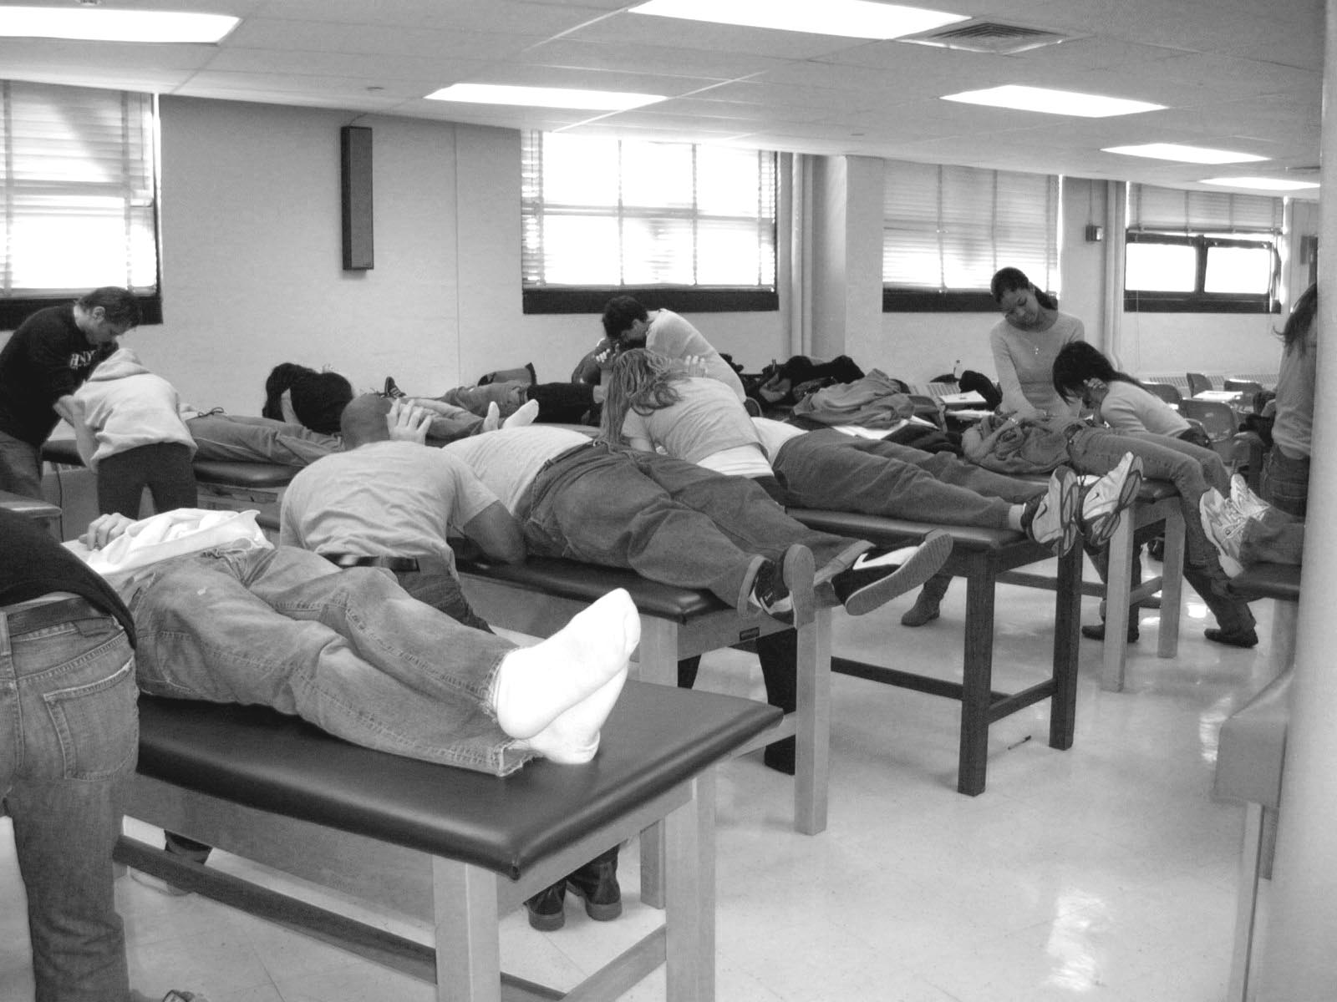

Donation and Information Response: Donations are fully tax deductible if you itemize your deductions. Your contribution may be earmarked toward any of the following (minimum donation for earmarking is $100):

⁭ Purchasing research and teaching equipment
⁭ Scholarship funds for recruiting targeted applicants
⁭ Emergency funds for students in serious financial
need!
⁭ May be used at the discretion of the Program
⁭ I would like my name inscribed on a plaque on an electric high-low treatment table designating my donation (minimum $500). Maximum of ten would be available.

If you would like to sponsor an annual scholarship for a student, or a significant donation toward a major piece of research/teaching equipment, please contact Dr. Krasilovsky. We are continuously modernizing our classrooms, lab equipment and research capabilities. Key equipment can cost $15,000 to $30,000 and more. Facilitate your classmates to contribute, as a class, one new major acquisition!

===================================

Name: ________________________________
Address: _______________________________
City & State: ___________________________
Zip Code: ___________________
Class of: ___________________

List information about yourself for future publication:

Donation of $_______ enclosed, made payable to the Hunter College Foundation. Indicate on the memo section of the check that this donation is for the H.C. Physical Therapy Program and mail to:
Dr. Krasilovsky, Director
Hunter College PT Program
425 East 25th Street
New York, New York 10010

Thank you for your support.

