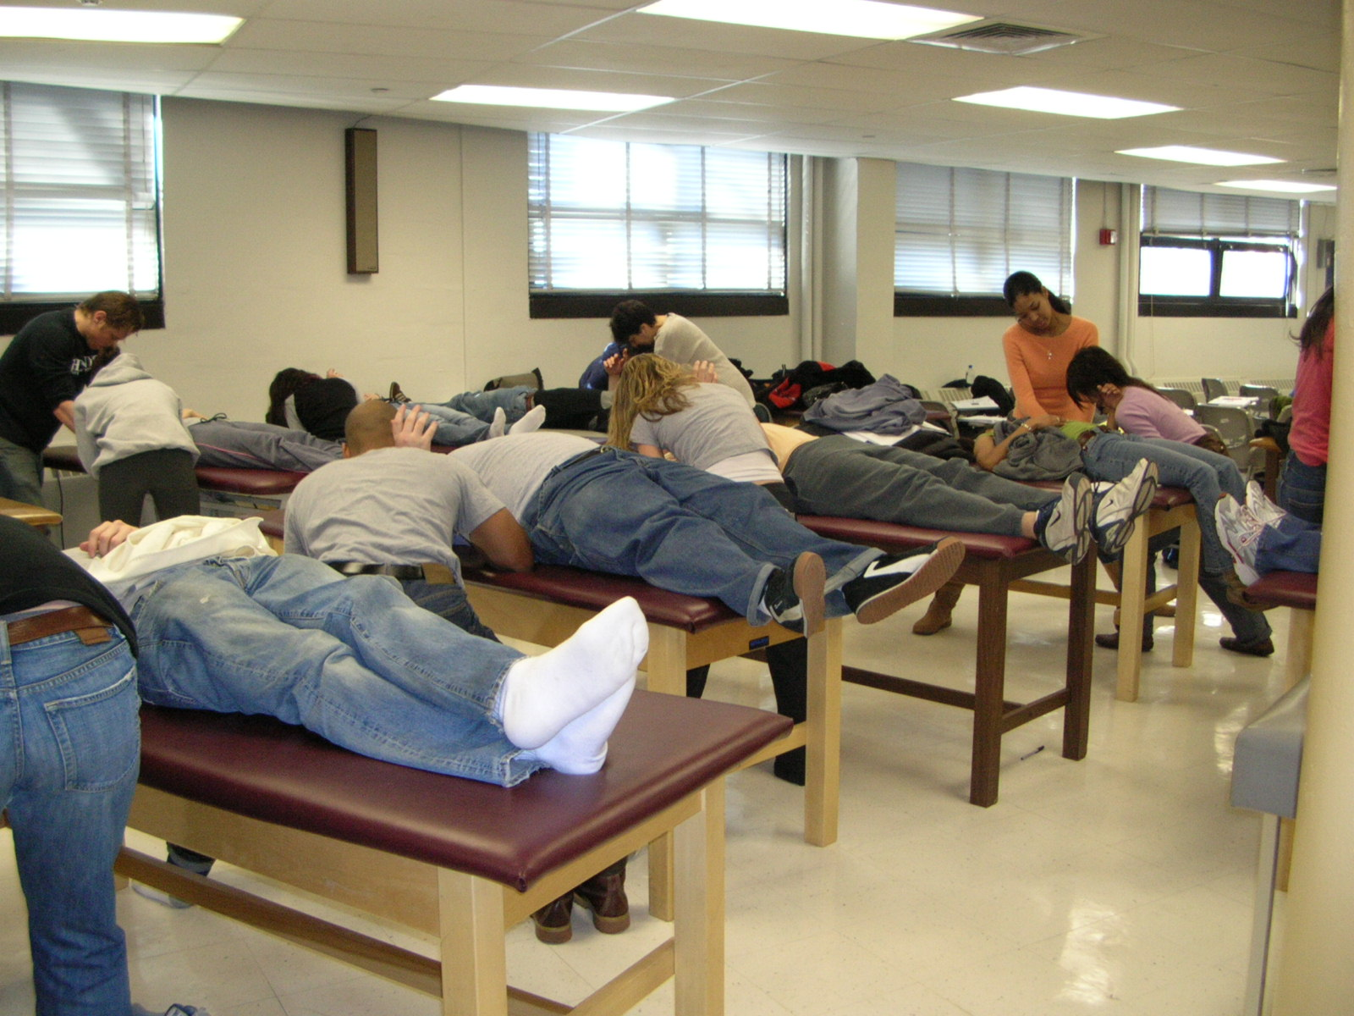
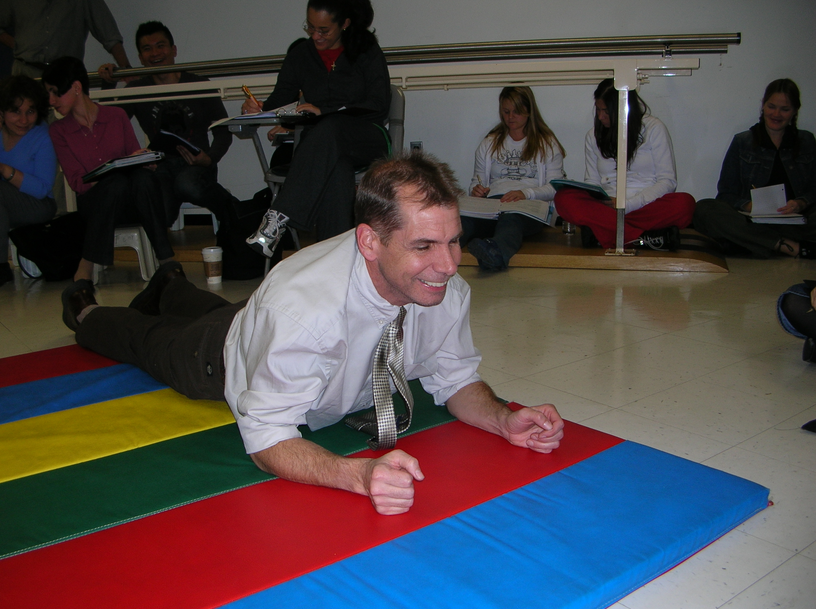
Hunter College P.T. Program Alumni Newsletter

The Hunter College P. T. Program Alumni Newsletter is issued approximately once per year. To contact the P.T. Alumni Association, send all correspondence to:
Hunter College P.T. Alumni Association, c/o P. T. Program, 425 East 25th Street, N.Y., N. Y.10010

Editor: Dr. Krasilovsky
email: PTProfessor@gmail.com

If you would like to participate in future editions of this newsletter, please contact Dr. Krasilovsky.

Hunter College P.T. Alumni Newsletter
From BS to MPT and now a DPT,
our curriculum is constantly evolving!

Vol. 4 No. 1
Fall, 2009

On behalf of all the faculty and staff, I hope this newsletter finds you and your family doing well in both your personal and in your professional life. Our program has continued to evolve into a strong, clinically and research based clinical doctoral program, and we take pride in our graduates and our alumni. This past June, we graduated our first class of DPT students. They worked hard throughout the three years of our program, pursuing clinical research and developing clinical skills appropriate for a doctoring profession. As in the past, many had multiple job offers before graduation, and performance on the National PT Licensing Examination continues to exceed the NYS average. Our dedicated faculty continue to work together as an effective team. We often encounter alumni at conferences, work sites or

just out in the community. It’s always a pleasure to see you and hear what you have been doing. We really do enjoy receiving these updates and encourage everyone to stay in contact with us. So send us cards, letters, pictures with updates on your life accomplishments. We’ll also include them in our next newsletter unless you tell us not to do so. Your classmates would also enjoy hearing what you’re doing post life as a student!

We welcome as a new member of our faculty Herb Karpatkin. Herb is just completing his doctoral degree (D.Sc) in neurology from Rocky Mountain University of Health Professions. His oral defense is scheduled for October. Herb has prior faculty experience in the Touro PT Program twenty years of clinical experience. He is board certified in neurology from the APTA and is a Multiple Sclerosis Clinical Specialist.

Mary Cleary has been with us since 200____, and she has become a key player in our team. As the initial experience applicants have in contacting us, Mary presents our program exceptionally well and is able to counsel most applicants better than anyone else at Hunter.

Dr. Krasilovsky

DPT Program Director
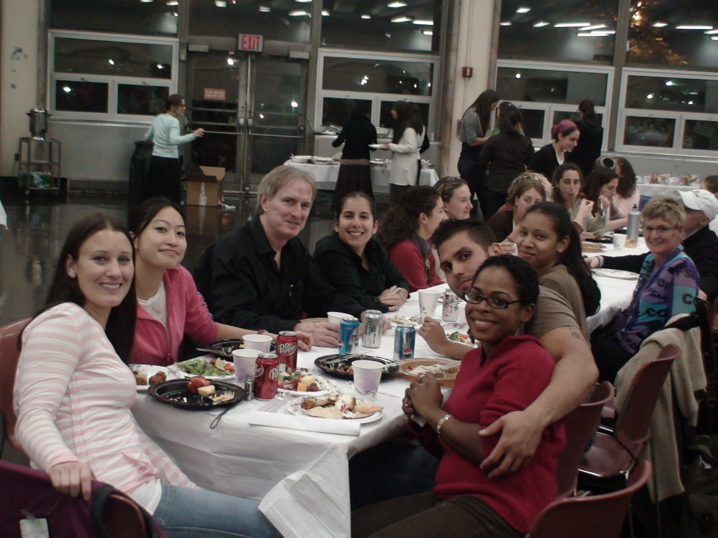
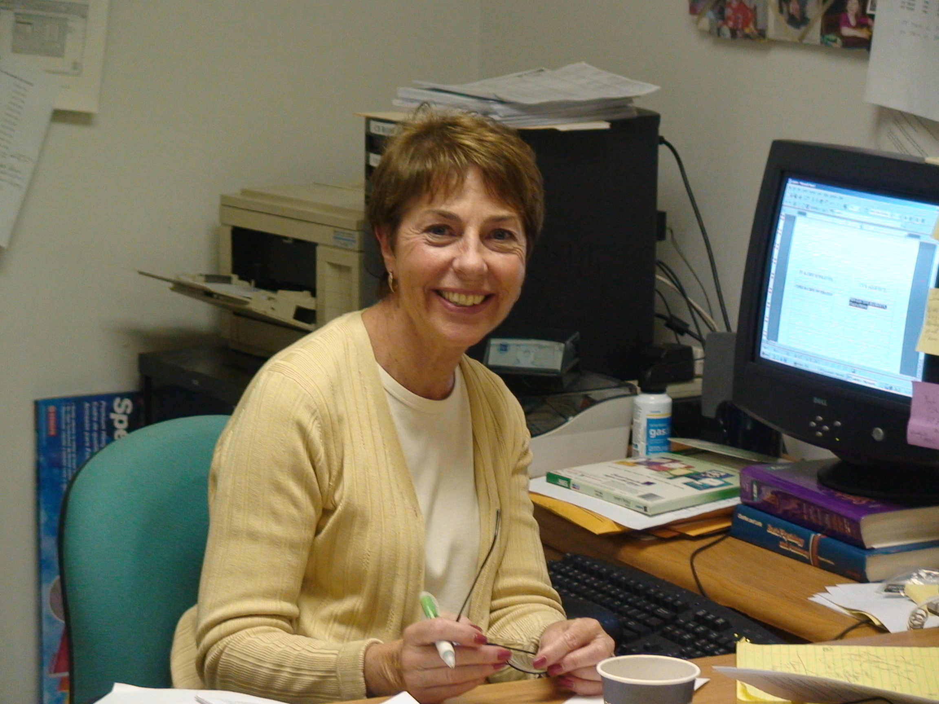
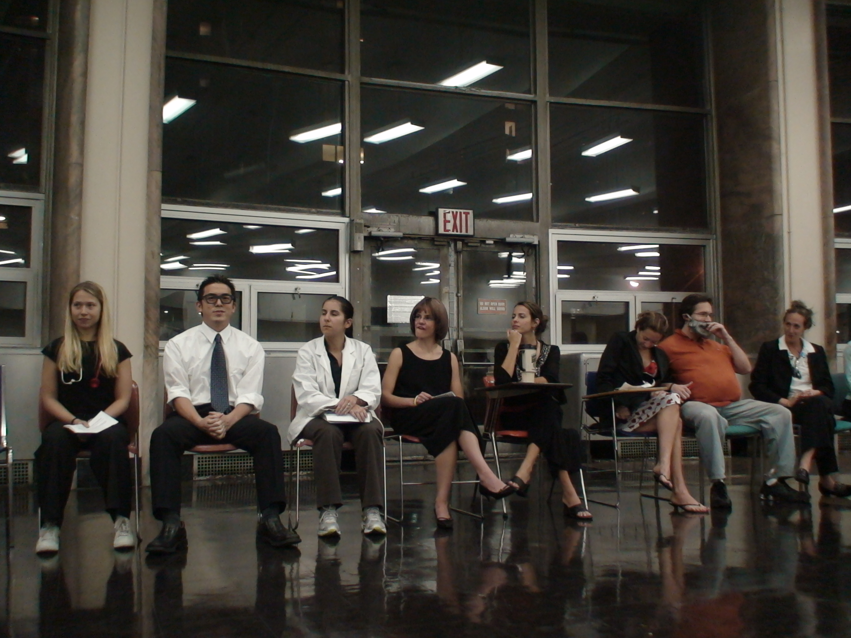
do enjoy receiving these updates and encourage everyone to stay in contact with us. So send us cards, letters, pictures with updates on your life accomplishments. We’ll also include them in our next newsletter unless you tell us not to do so. Your classmates would also enjoy hearing what you’re doing post life as a student!
We welcome as a new member of our faculty Herb Karpatkin. Herb is just completing his doctoral degree (D.Sc) in neurology from Rocky Mountain University of Health Professions. His oral defense is scheduled for October. Herb has prior faculty experience in the Touro PT Program twenty years of clinical experience. He is board certified in neurology from the APTA and is a Multiple Sclerosis Clinical Specialist.
Mary Cleary has been with us since 200____, and she has
become a key player in our team. As the initial experience applicants have in contacting us, Mary presents our program exceptionally well and is able to counsel most applicants better than anyone else at Hunter.

Dr. Krasilovsky
DPT Program Director

Our esteemed faculty as perceived during our annual thanksgiving party

Mary Cleary, our secretary and lots more.

Vol. 4 No. 1
Fall, 2009

Thanksgiving Party - an annual tradition with great entertainment.
Visit and subscribe to one of our web sites:
www.hunter.cuny.edu/schoolhp/pt
You can subscribe to our PT Internet List Serve, which can be used by alumni, students and faculty to issue announcements, communicate with each other, plan meetings, etc. To subscribe (no charge), send an email to: majordomo
@.hunter.cuny.edu In the message section, type exactly: subscribe pt-l (l is the letter L). You can send a posting to all members of the mailing list by sending email to: pt-l@hunter.cuny.edu

Programmatic Activities:

We enrolled our first class of students in our DPT program in the summer of 2006 and they graduated this past June. This DPT program is in collaboration with the Graduate Center of CUNY, which is the only CUNY institution that issues doctoral degrees. This new curriculum replaces our MPT curriculum that started in the Fall of 2000. All students enter the graduate DPT program with a bachelor’s degree in any major. The curriculum is three years long, including summers. This is a very significant change from any bachelor’s degree program. The greatest change from our MPT curriculum is a research requirement (students must work in small groups and carryout clinical research), expanded cardiopulmonary content, clinical decision making, and an integumentary course. Our MPT curriculum was designed to be equivalent to many DPT programs, so when we transitioned to the DPT, we only enhanced the curriculum.

If you would like to read more about our DPT curriculum, please go to our website. If you know someone who is applying, recommend to them that they come in for one of our informational sessions. The dates are posted on the homepage of our website.
Research Collaboration with the Hospital for Special Surgery and NYU Medical Center

Many of you remember shlepping up to the Hospital for Special Surgery for our Orthopedics course. Our students still continue to travel there for our two orthopedics courses, but we also have established a research collaboration with the Department of Rehabilitation Medicine. Our students and faculty are working with the physical therapy and rehabilitation staff at HSS on collaborative, clinical research projects. This allows support for clinicians to collect, analysis, and publish clinical research, and use this information to make clinical decisions about PT practice. Our students and faculty will be participating in these projects, exposing students to meaningful research endeavors and eventual publication of the manuscripts. We have also established similar research collaboration with New York University Medical Center, Cornell Weill, ......... We expect to and are interesting in expanding these research collaborations with other institutions. These are win-win collaborations for our students, faculty, the institution and the profession by facilitating clinical research at patient care centers. Our DPT students and research mentors at the facilities are the key components of these collaborations.

Post-Professional DPT:
We are not offering our own post-professional DPT curriculum for alumni. Those of you interested in earning this higher degree and updating your education have probably already pursued other available programs. In order to assist our alumni in this process, Dr. Krasilovsky has established letters of agreement with some of these post-graduate programs. They have reviewed our curriculum and determined that some courses you completed in your entry level program at Hunter College were equivalent to a
course in their t-DPT (or post-professional DPT) program. These articulations include SUNY Stonybrook and Des Moines University (an online program). More details on the programs that have completed these reviews and the courses they are waiving are posted on our website (click on the alumni page).

Recent Faculty Activities:

The faculty, individually and collaboratively, have been very active in teaching, research, publishing, service to the College and the profession. A listing of our most recent publications are listed separately in this newsletter. All faculty are members of the American Physical Therapy Association.

Suzanne R. Babyar Rothbart, PT, PhD has been with the Physical Therapy Program since 1992, when she completed her doctorate in Physical Therapy from New York University. Her teaching has focused on two areas: neurological evaluation and intervention for the adult patient and joint examination and treatment. In 2004, the New York Physical Therapy Association awarded her the Outstanding Service to Chapter for her work with the Research Committee. She enjoyed a sabbatical at Burke Rehabilitation Hospital (White Plains, NY) where she developed investigations relating to “pusher syndrome’ or lateropulsion following stroke. She continues to collaborate with the therapists on the Stroke Unit and with its Director, Michael Reding, MD. With the help of release time from teaching during the 2005-2006 academic year, she was able to complete two studies with this population and start another one with patients with unilateral neglect following stroke. She presented one of the studies as a poster at the International Stroke Conference,
Vol. 4 No. 1
Fall, 2009
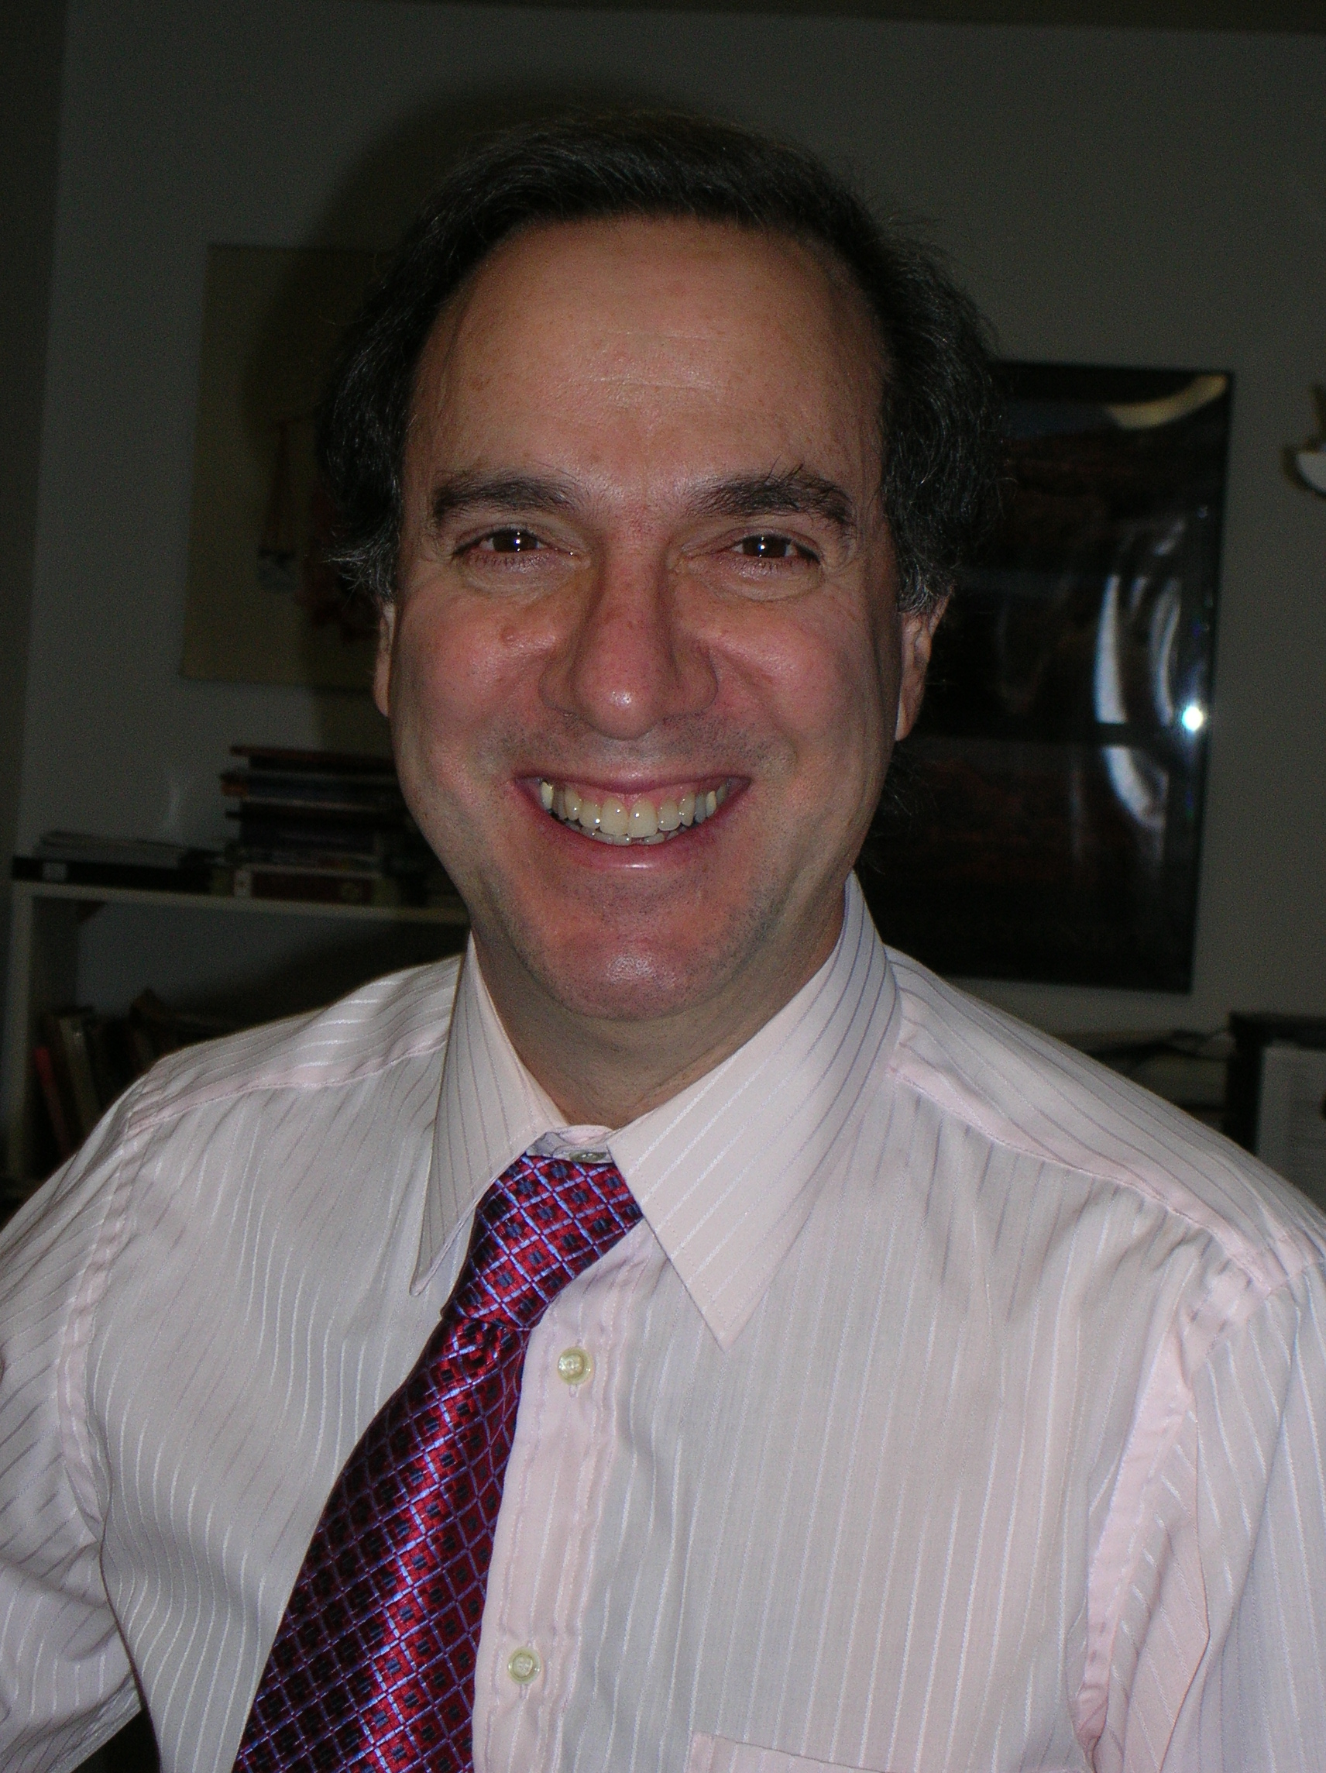

Vol. 4 No. 1
Fall, 2009
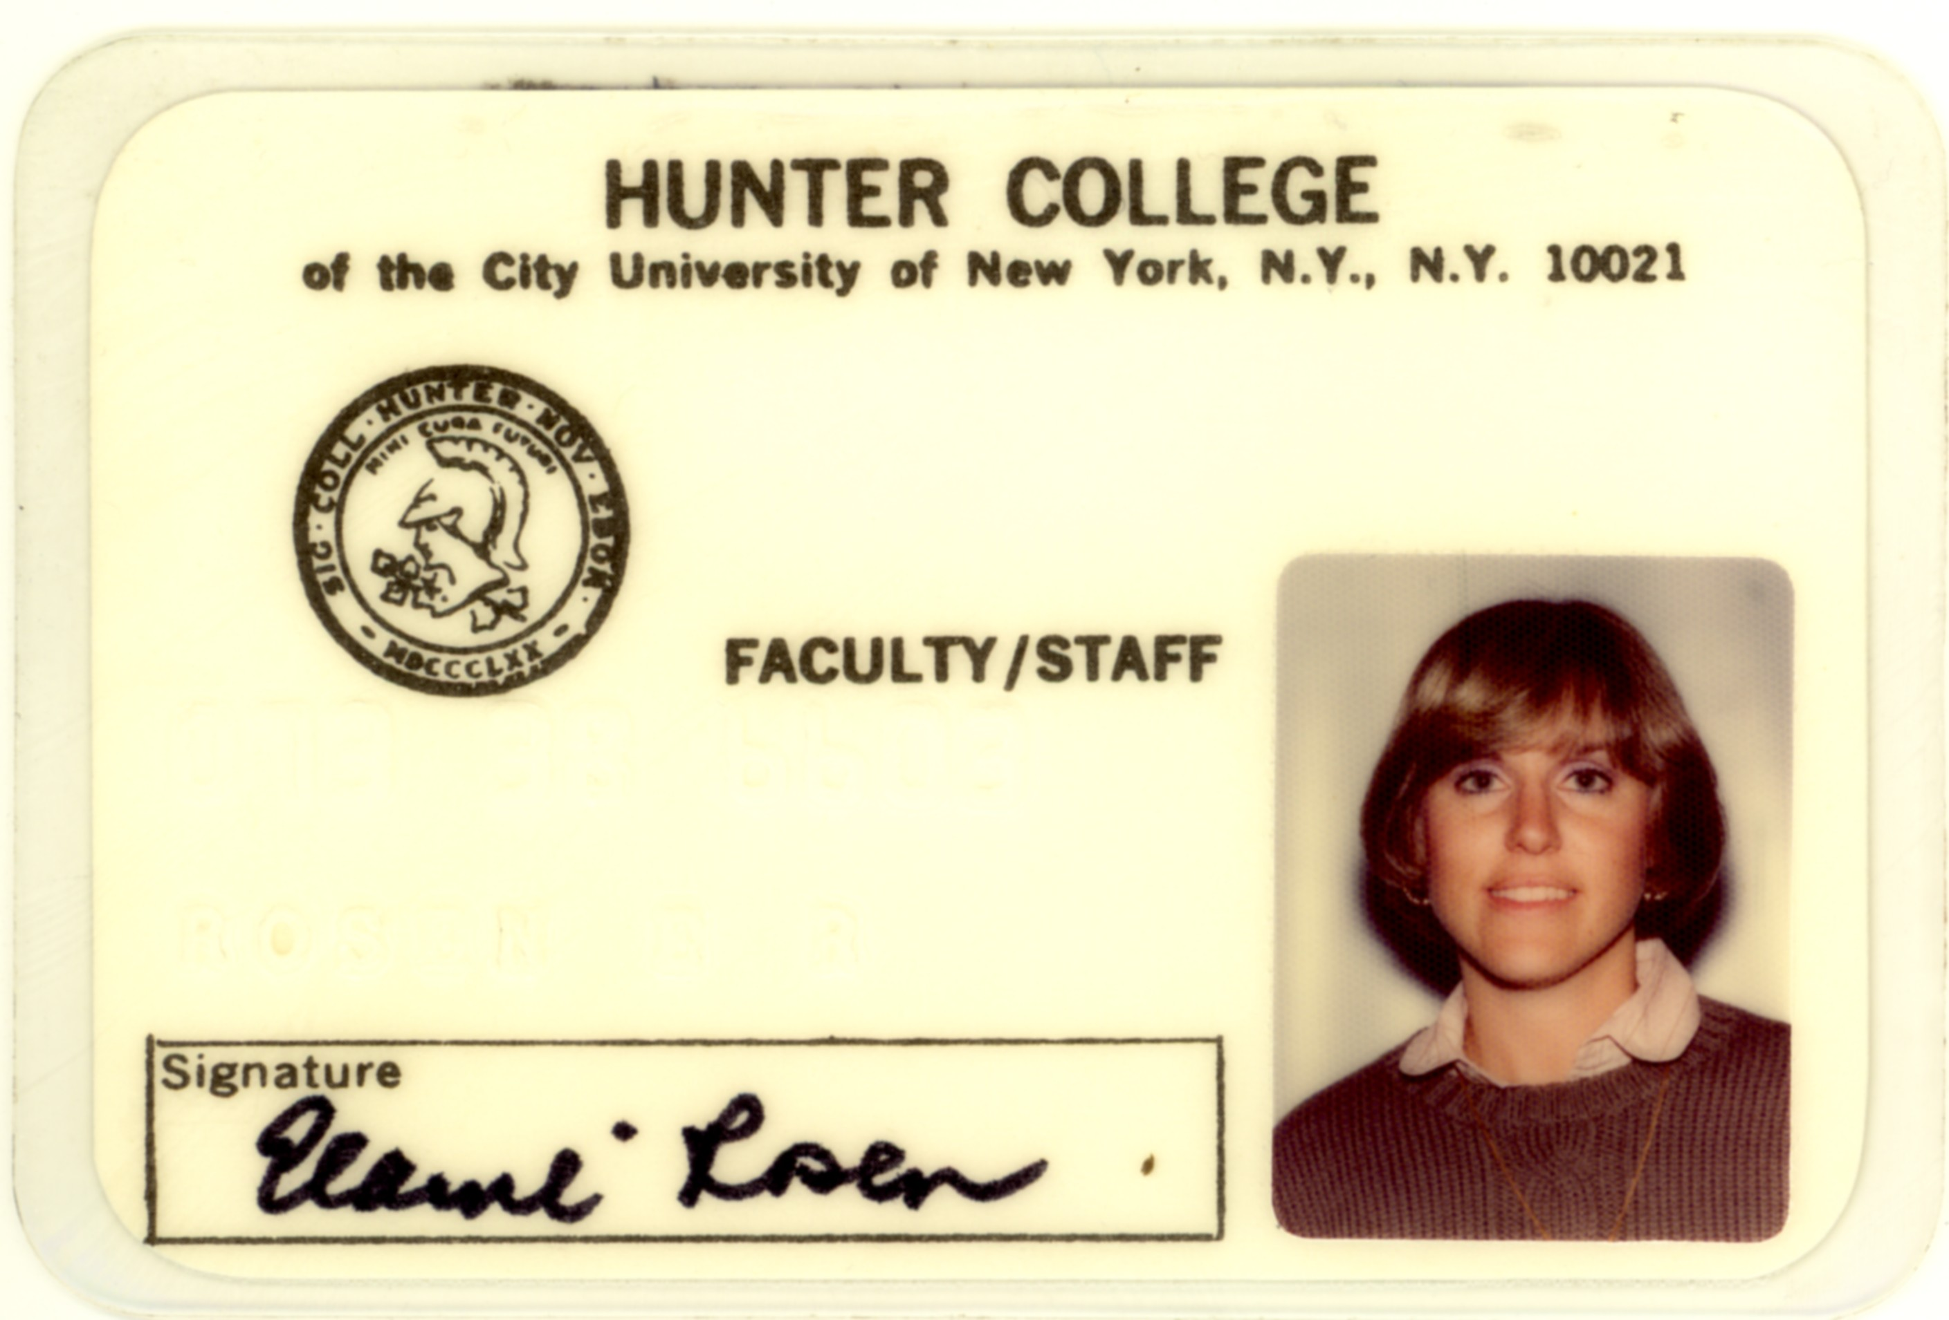

Vol. 4 No. 1
Fall, 2009
Elaine Rosen, PT, DHs, OCS, FAAOMPT
Dr. Rosen earned her DHSc at the University of St. Augustine, Florida. She was a Recipient of the (Orthopedic Section, APTA) James A. Gould Excellence in Teaching Orthopedic Physical Therapy Award in 2003. She continues to be responsible for teaching the orthopaedic manual therapy track.
Dr. Rosen was promoted to full professor beginning January, 2010. She also successfully re-certified as an Orthopaedic Clinical Specialist and as a Fellow of the American Academy of Orthopaedic Manual Physical Therapists.
The third edition of her text Musculoskeletal Examination was released and the second edition was translated into Chinese in addition to an additional 6 languages. She served as associate editor for Musculoskeletal Essentials: Applying the Physical Therapists Preferred Practice Patterns in 2006 and assistant editor for Neuromuscular Essentials: Applying the Preferred Physical Therapy Practice Patterns in 2008.
Lipovac, M.N., Reith, M.E.A., and Lajtha, A. (2006) Metaphit induced seizures and transport of GABA across the blood-brain barrier. Neurochemistry International

Mehreteab TA, Holland T. (2006) Effect of electrical stimulation on nerve and muscle. In: Hecox B, Mehreteab TA, Weisberg J, Sanko J, eds. Integrating Physical Agents in Rehabilitation. 2nd edition Upper Saddle River, NJ: Prentice Hall.

Mehreteab TA, Holland T. (2006) Iontophoresis. In: Hecox B, Mehreteab TA, Weisberg J, Sanko J, eds. Integrating Physical Agents in Rehabilitation. 2nd edition Upper Saddle River, NJ: Prentice Hall.

Mehreteab TA, Holland T. (2006) Clinical uses of electrical stimulation. In: Hecox B, Mehreteab TA, Weisberg J, Sanko J, eds. Integrating Physical Agents in Rehabilitation. 2nd edition Upper Saddle River, NJ: Prentice Hall.

Mehreteab TA, Holland T. (2006) Therapeutic electricity. In: Hecox B, Mehreteab TA, Weisberg J, Sanko J, eds. Integrating Physical Agents in Rehabilitation. 2nd edition Upper Saddle River, NJ: Prentice Hall .

Rosen, ER, Rusnak Smith SE. Practice Pattern B, Impaired Posture In Moffat, M, Rosen, E, Rusnak-Smith SE (2006) Musculoskeletal Essentials: Applying the Physical Therapists Preferred Practice Patterns, Thorofare: NJ, Slack Publishers

Sziraki I, Hashim A, Sershen H, Allen D, Cooper T, Lipovac M, and Lajtha A. Strain differences in sensitivity of central dopamine systems to nicotine in Lewis and Fischer 344 rats. In Monitoring Molecules In Neuroscience, Eds: Jan Kehr, Kjell Fuxe, Urban Ungerstedt, Torgny Svensson. Karolinska Institute, Stockholm Sweden, Proceedings of the 10th International Conference on In Vivo Methods, 143-145, 2003.

Published Abstracts and Presentations
Abstracts:
Babyar SR, Reding M. (2005). Effect of Lateropulsion on Stroke Rehabilitation Outcome. Neurorehabilitation and Neural Repair. 19:380.

Moore E, Feld J, Babyar SR, Jordan B. (2005). Relationship of the Berg Balance Scale Items and Outcomes for Individuals with Acquired Brain Injury in an Acute Rehabilitation Setting. Neurorehabilitation and Neural Repair. 19:378.

Presentations:
Pivko, S., Silberman, N., DeMasi, I., Taylor, M., Jain, A.
The Prerequisites,
Performance and Perceptions of the ACCE/DCE in Emerging DPT Programs
National Education Leadership Workshop, Washington, DC, Oct, 2006
APTA Combined Sections Conference, Boston, MA,Feb 2007
World Physical Therapy 2007 Conference, Vancouver, BC Canada.
June, 2007
American Physical Therapy Association Annual Conference, Denver, Colorado, June, 2007.

Recker-Hughes, C., Pivko, S., Mowder-Tinney, J.J .,Brookes, G. (2007) Clinical
Instructors’ self-perceptions of competence in teaching core content areas of curriculum to professional DPT students: Implications for academic
programs.
World Physical Therapy 2007 Conference, Vancouver, BC Canada.
June, 2007

Babyar, S.R., White, H., Shafi N., Reding, M. (2007, Stroke). FIM™ Efficiency Lower in Patients with Stroke and Lateropulsion: A Case-Matched Controlled Study.
International Stroke Conference. San Francisco, CA. February 7-9, 2007.

P. T. Adjunct Faculty
We would like to acknowledge the participation of our adjunct faculty who have continued to make significant contributions to our Program:

Marc Campo PT, MS, OCS
Elizabeth Dominick, DPT, PT, NCS
Amy Drum, MPT
Greg Gao, MD, PT
Amy Hess, MS, PT
Michael Ingino, MBA, PT
Karilyn Hildebrand, PT
Barbara Karpinska, PT
Kristine Kinsley, PsyD
Paca Lipovac, MD, PT
Martha Macht Sliwinski, PhD, PT
Jeme Mosca, MBA, PT
Keith Peterson, MPT

Teresa Smith, MS, PT, NCS

Department Renovations
The lower level of the East building was totally renovated during the summer of 1998. This includes modern heating,
Vol. 4 No. 1
Fall, 2009
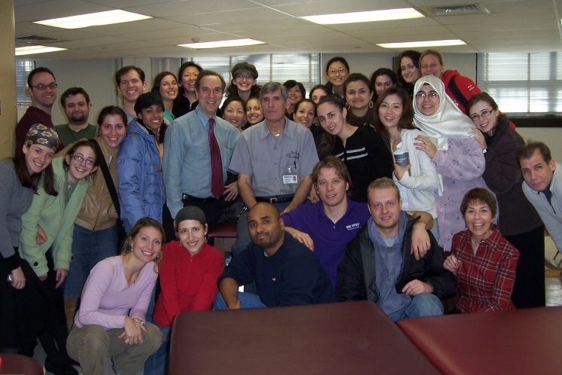

lighting, air conditioning, new walls and floors. A new P. T. classroom and two additional faculty offices have also been constructed. This completes the modernization of the classroom and office equipment and establishment of a motion analysis laboratory. We now have a very modern teaching and research environment for students and faculty.

New Health and Science Building:
Recently, plans have begun to materialize for a new Health Professions and Science building two blocks away from the main campus. All Brookdale based programs would eventually move into a new building that is presently in the planning stages.

Open House For Alumni

We are planning an open house for all alumni. You will have an opportunity to tour our new facilities and meet the faculty and other classmates. More information will be mailed separately.

If you are interested in speaking at high schools, colleges, or other organizations about physical therapy or about the
Hunter College PT program, please contact us. We may be able to provide you with up-to-date information and we have physical therapy visual aids (such as videotapes, slides, brochures). We are especially interested in attracting students from under-represented groups. We need alumni assistance in this, especially mentors for future applicants.

George Retires
George, our caretaker for many years, retired in 2007. We gave him a retirement party, complete with gifts from the faculty and students. He was really touched by our display of wishing him well as he moves into his new lifestyle.

Alumni Activities
Please let us know what you are doing professionally and/or personally. See it in print here in our next edition.

1990's:
Bonnie Jaffee (90) is married, has a
baby girl and completed her MS in Developmental Disabilities at NYU.
Ihor Strutynsky (92) works for the VNS and lives in the Bronx. He is certified in Lymphedema management.
Barbara (Boucher)Galm (92) is married with two children, employed part-time (and working full time). She lives in Pine Plains, NY.
Kathleen Beebe (93) is married and attended medical school at Columbia University. She graduated in May, 1999.
Pamela Ross (93) is married and has one baby boy. She is living in Florida.
Kayla Cynamon (93) is supervisor at N.Y. Center for Pain Management, Brooklyn.
Tamar Schwell (93) is working at an out-patient clinic in Jerusalem.
Patty Lue Shue (94) has completed her MS at LIU and is now a Director at Bellevue Hospital.
Eli Rothblat (95) is working for VTA and lives on S. I. He is working toward a MA degree in administration at Baruch.
Kirsten Rasmussen Watts (95) is married, living in California and working at Kaiser Hospital.
Denise (Cogan) Hanchet (95) had a baby boy and works at Central Park PT and teaches in the Dance
Program at Hunter and NYU.
Mimi Seif (95) has two daughters and is PT Supervisor at Shorefront Jewish

Vol. 4 No. 1
Fall, 2009
Margaret Duncan (85) is Chief PT at Albany VA Medical Center. She is married since 85, has two children and is active in clinical education and orthopedics.
Irene Martin (84) is working in Orange, CA.
Debra Mattingly (82) is married and has a new baby boy. She is living and working in Charleston, West Virginia.

1970's
Melissa Liberman received an MS in PT from LIU in 1977 and works in Bklyn.

Please network with other members of your class and have alumni contact us who do not receive this mailing.

We also need class liaisons. We have funds to underwrite an activity for the alumni, and need your assistance to re-energize this association. If you’d consider helping again, please contact Elaine Rosen. We can send you our most recent class address listing.

Donations We would like to be able to acknowledge donations from our alumni. We don’t always ask, but with a reduction in support from our tuition, we do need additional
support to meet the needs of our students and faculty. Please support your Program. We will need to purchase additional technology for our new classroom and research laboratory. This would be a great opportunity for you to show their support. Indicate in the memo section on the check that the donation is for the H. C. Physical Therapy Program. Mail it to the address on page one. Thanking you in advance for your support. Please use the form on the last page.

Recent Donations:
Mitchell Cuan $100

Feedback and Information Wanted:

We are continually seeking feedback from our alumni on various curriculum and professional issues.

Would you like us to consider co-sponsoring certain continued education courses?

Have you taken a new job you’d like your classmates or us to know about? We’d very much like to know where our alumni are working, and what type of jobs you have.

Vol. 4 No. 1
Fall, 2009

1999 - No award given
1998 - Mitchell Maione
1997 - Claudine Munoz
1996 - Lisette Alvarez
1995 - Cathy Greeley
1994 - Gerard Williams
1993 - Christine Dukles-Banta
1992 - Keith Seltzer
1991 - Michilina Martucci
1990 - Chris Tang
1989 - Mark Thompson
1988 - Catherine Quinn
1987 - Frances Baratta
1986 - Kim Kiamie
1985 - Teresa Errigo
1984 - Anne Lancellott
1983 - Julie Stelley
1982 - Patricia Kuhl
1981 - Donna Panarello

School of Health Science Awards

James Felt Memorial Scholarship for Merit:
Keith Heischober (’09)

James Felt Memorial Scholarship for Achievement: David Ruderman (’08)

Beatrice Konheim Scholarship: Kendall Black (’07)

Professional Issues of Concern:

Get more involved in the APTA. This is your profession, and NYPTA and APTA are our primary advocate about legislative issues. You should also become more active in educating the public about physical therapy. It’s your future. Why do many people have “their Chiropractor” but not their favorite Physical Therapist?

Vol. 4 No. 1
Fall, 2009

