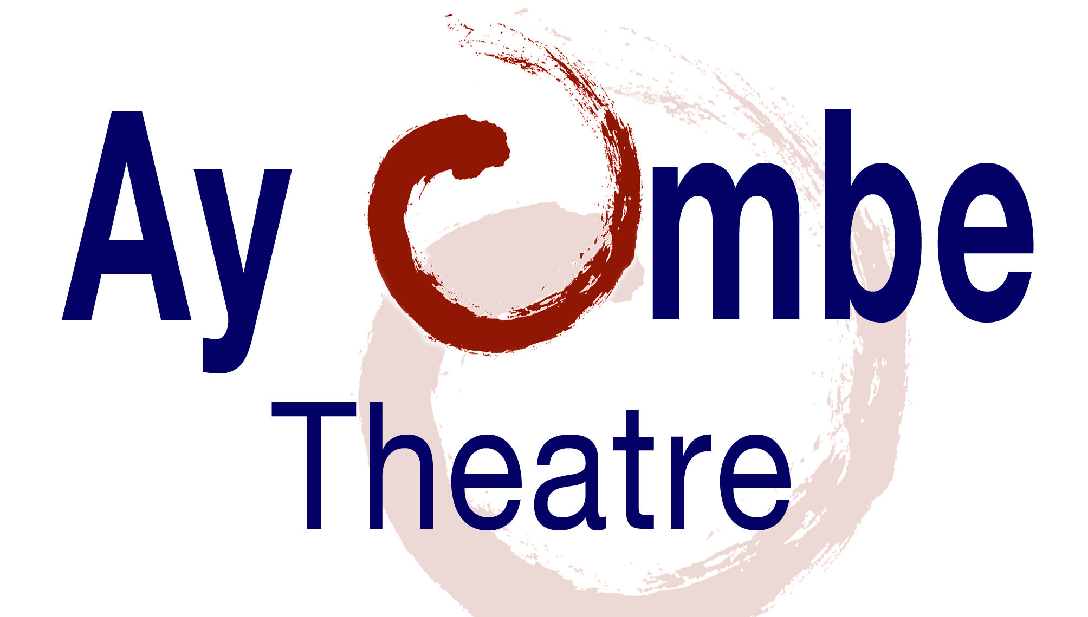
Ay Ombe Theatre
Press Release

Ay Ombe theatre´s I OM BE Press, with great delight presents Levente no. Yolayorkdominicanyork. The book is a close relative of the blog kept by its main character, Quisqueya Amada Taína Anaísa Altagracia, since 2008. Also known as “la Kay” and “la Gorda”, Quisqueya Amada Taína Anaísa Altagracia tells the stories of the people living in her building, El Ni ‘e. In the words of the 2008 Pulitzer Prize winner Junot Díaz:

"Josefina Báez has been breaking open hearts and re-ordering minds for more years than I care to count.
She is one of North America's finest artists and she is, without question, one of my favorite writers.
She is a sword bathed in flame, she's a marvel.
Levente no.Yolayorkdominicanyork is her finest work yet."

Josefina Báez is a gifted writer and performer. Her acclaimed book and performance, Dominicanish, has been hailed as a vital document on contemporary and post-modern literature. Her second book, Comrade, Bliss ain´t playing has been praised for its beauty and exquisite vulnerability. Its unique language has delighted scholars and the public at large locally, nationally, and internationally. Mrs. Báez (La Romana, Dominican Republic/New York) directs Ay Ombe Theatre since April 1986.

The book is on sale only at (Preview the book too):
http://www.blurb.com/my/book/detail/1966417/#book-settings
Other books by I OM Be Press:
http://www.blurb.com/user/store/ayombe

Levente no.Yolayorkdominicanyork photos by Giovanni Savino.

