

FRENCH TUTORING

Fridays 2:00pm – 5:00pm Goycoechea

**Chanin Language Center Library B126 HW**

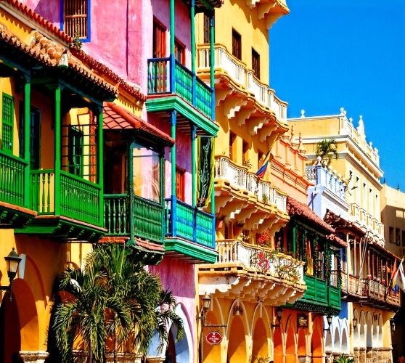

SPANISH TUTORING

Tuesdays 1:00pm – 4:00pm Goycoechea

Wednesdays 4:00pm – 7:00pm Goycoechea

Thursdays 1:00pm – 4:00pm Goycoechea

**Chanin Language Center Library B126 HW**

ITALIAN TUTORING

Tuesdays 9:30am – 10:30am Fogliani

2:30pm – 3:30pm Fogliani

Fridays 2:30pm – 3:30pm Folgiani

**1324 Hunter West**

