THE ROMANCE LANGUAGES DEPARTMENT INVITES YOU TO
AN EVENING ON GLOBAL MIGRATIONS

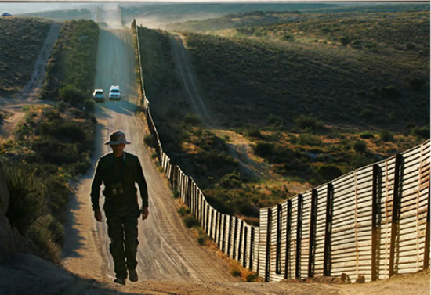

4:10. Round Table: Creating community through education and art

Daisy Bugarin. Director of They Tried To Bury Us. They Didn’t Know We Were Seeds, film centered on the 43 “desaparecidos” in Ayotzinapa.

Aracelis Lucero. Executive Director of Masa & member of the Mexica Danza Community.

Elizabeth Rodríguez. Bordando por la Paz // Embroidering for Peace.

5:35. A Right to Safe Haven. Widney Brown. Physicians for Human Rights.
.
7:00. El viaje y la llegada a Nueva York. Zaida Cortés. El Diario, New York.

Wednesday October 14th 2015 HW. B 126

