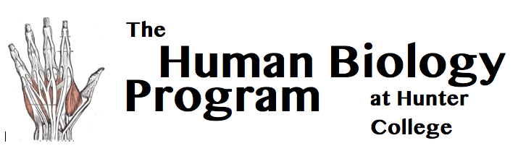 | Room 757 Hunter North 695 Park Avenue, NY, NY 10065 212.772.5418 humbio@hunter.cuny.edu
Internship (HMBIO403)
Bring this completed form to the Hum Bio Office hours
before the beginning of the semester that you would like to enroll.

Student Name: EMPLID: Email: Date:

Schedule: Start Date: End Date: Hours/Week: Total Hours:

Semester: Year: Credits (1-3): (∼40h=1 Cr., ~  ~120h=3 Cr.)

To Be Filled out by SUPERVISOR

Supervisor Name: Organization: Email:

Please supply a 1 paragraph preliminary description of the student’s responsibilities as an intern and the educational nature of their internship. (You may use this form or send an email to humbio@hunter.cuny.edu).

The hourly schedule provided above is accurate. I agree to fill out an online evaluation of the student’s performance by Dec 10th (Fall Sem.), May 10th (Spring Sem.) or August 21th (Summer Sem.). I have read the second page of this document, which provides information regarding Hunter’s Policy Against Discrimination and Harassment and how it relates to external entities such as your organization.

Supervisor Signature: . Date :

To Be Filled out by STUDENT

I agree to send a 1-3 page paper (one page per credit) describing the internship, its educational nature, and its relationship to the Human Biology major by Dec 10th (Fall Semester), May 10th (Spring Semester) or August 21th (Summer Sem.). I understand that without this paper and without the supervisor’s end of semester evaluation, I will be given an INC grade.

Student Signature: . Date :

Hum Bio Advisor Name:

Hum Bio Advisor Signature:

Date:

Program Stamp:

Hunter’s Policy Against Discrimination and Harassment

As you may know, Hunter College is committed to providing a quality and affordable education to all students. We are pleased to be affiliated with organizations such as yours who share this value, help us pursue this commitment and work with us to provide Hunter students with placements relevant to their discipline, academic interests or field of study and which fulfill an academic requirement.

Hunter and its parent organization, the City University of New York (CUNY) are committed to fostering a learning and working environment where all students and members of the academic community can achieve their highest potential, free from any kind of discrimination, including sexual harassment of any kind. CUNY’s Policy on Sexual Misconduct prohibits sexual misconduct of any kind, including but not limited to sexual harassment, gender-based harassment and sexual violence. Pursuant to this Policy, Hunter encourages the prompt reporting of any such act, promptly responds to and investigates any such allegation, makes efforts to prevent the recurrence of any sexual misconduct and provides appropriate support and service to affected students. The CUNY Policy on Sexual Misconduct can be found at the following link: http://www2.cuny.edu/wp-content/uploads/sites/4/page-assets/about/administration/offices/legal-affairs/POLICY-ON-SEXUAL-MISCONDUCT-10.1.2015-with-links.pdf

The CUNY Policy on Sexual Misconduct applies to Hunter students and members of the CUNY community while they are at your organization engaged in an educational program, activity or service, such as internship placements. We recognize that your organization may have its own organizational policies which govern discrimination or sexual misconduct and we want to make sure that you understand and appreciate the reach of the CUNY Policy on Sexual Misconduct and that it extends to cover Hunter students placed at your organization.

We expect a coordinated effort in responding to allegations or incidents that may arise at your organization during the course of the student placement. To the extent we at Hunter learn of an incident or allegation, we will promptly inform you, providing such particulars and details as we are aware as well as our decision as to what appropriate protective action is required to keep the student safe (including removal from the placement). We would look to your organization to assist us in reviewing and investigating the incident or allegation based on the information we provide (as well as such additional information you may develop) and to advise us of information you gather and/or conclusions you reach. To the extent that your organization learns of an incident or allegation involving a Hunter student, we would appreciate your promptly notifying the Human Biology Director, Prof. Michael Steiper (msteiper@hunter.cuny.edu) so we can assess the situation and provide support to the student pending the investigation. In either event, we stand ready to fully cooperate with you to provide for the safety of the student, stop the offending conduct, prevent its recurrence and, where appropriate, pursue appropriate disciplinary action or other remedial measures. If you have any questions or wish to discuss this further, please do not hesitate to contact me or the Hunter College Title IX Coordinator, John Rose, who can be reached at: john.rose@hunter.cuny.edu.

