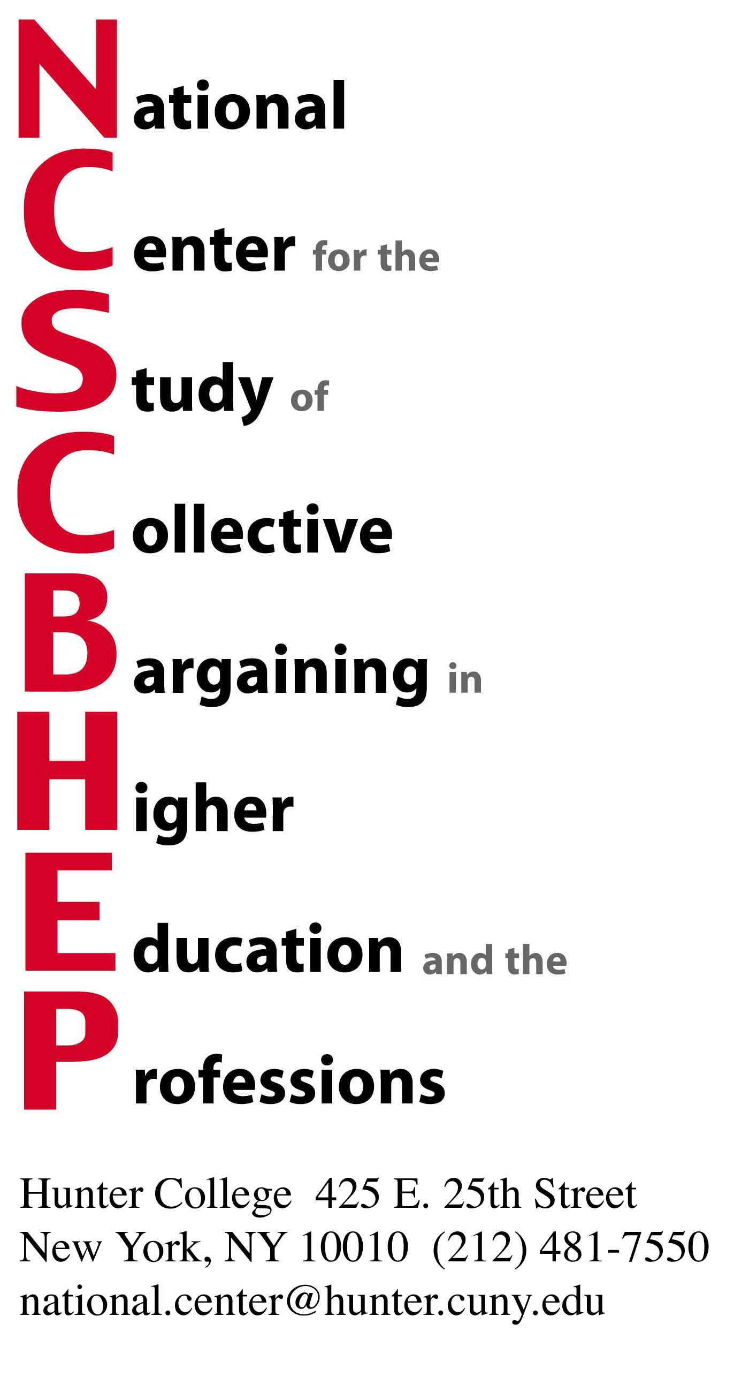

Dear Colleagues and Friends of the National Center,

This year we have again reserved room blocks at the Affinia Dumont and at the Affinia Shelburne Murray Hill Hotels.

Internet Reservations:

- For the Affinia Dumont go to: https://gc.synxis.com/rez.aspx?Hotel=10151&Chain=5158&Dest=ADumont&group=NATL12 or
- For the Affinia Shelburne Murray Hill go to: https://gc.synxis.com/rez.aspx?Hotel=10146&Chain=5158&Dest=Shelburne&group=NASH12
- Choose the Arrival and Departure Dates
- Choose the number of Adults and Children (maximum of two people)
- Click on Continue, room rate is $269.00/night (lower rate than last year)
- Click on Continue, complete the registration process
- Click on Book Reservation

E-mail Reservations:
reservations@affinia.com, mention the group name: National Center for the Study of Collective Bargaining, and indicate either the Affinia Dumont or the Affinia Shelburne Murray Hill

Phone Reservations:
1-866-233-4642 and mention the group name: National Center for the Study of Collective Bargaining, and indicate either the Affinia Dumont or the Affinia Shelburne Murray Hill

We urge you to book your rooms early.

We look forward to seeing you in New York.

Sincerely,

Dr. Richard Boris
Executive Director

