34th Annual Conference Location Map

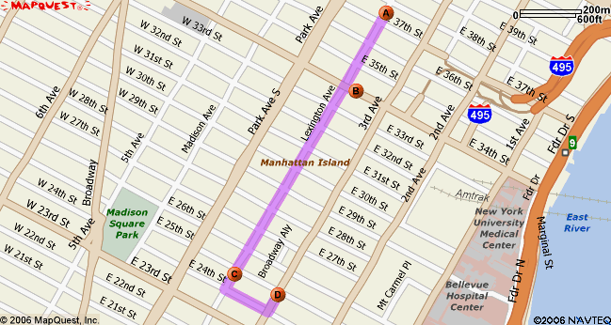

A Shelburne-Murray Hill Hotel, 303 Lexington Ave, New York, NY 10016, 212-689-5200

B Affinia Dumont Hotel, 150 E 34th St, New York, NY 10016, 212-481-7600

C Baruch College, 55 Lexington Ave, New York, NY 10010, 646-312-1000

D Hairy Monk Bar, 337 3rd Ave, New York, NY 10010, 212-532-2929 (Please note correct address NOT Lexington Avenue)

Easy walking distance between hotels and Baruch (and Hairy Monk); or Lexington Avenue buses: #101, 102, 103 (downtown) or 3rd Avenue buses: # 101, 102, 103 to return to hotels (uptown); taxis too. Subway: Lexington Avenue local #6 (downtown) to 23rd Street, (uptown) to 33rd Street

Subway and Bus map:
http://www.mta.info/nyct/maps/manbus.pdf

Map of Baruch College

Conference Site: Vertical Campus (entrance on corner of 24th Street and Lexington Avenue)

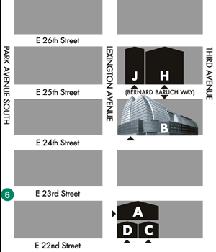

Parking Garages near Baruch College
330 Parking Corp.
(Between 24th & 25th Street)
330 3rd Avenue New York, NY 10010 (212) 696-0056
Charles Parking
(Between 3rd & Lexington)
200 East 26th Street New York, NY 10010 (212) 751-1080
East 26-29 Garage Corp.
(26th Street)
462-490 Second Avenue New York, NY 10010 (212) 252-8038
R.O.F.R.E Corp.
(Between 2nd & 3rd)
242 East 25th Street New York, NY 10010 (212) 779-2966
Quik Park
(Between 23rd & 24th Street)
23-24 Second Avenue New York, NY 10010 (212) 683-4009
Penny Lane Car Park
(Between 2nd & 3rd Ave.)
215 East 24th Street New York, NY 10010 (212) 996-6363

