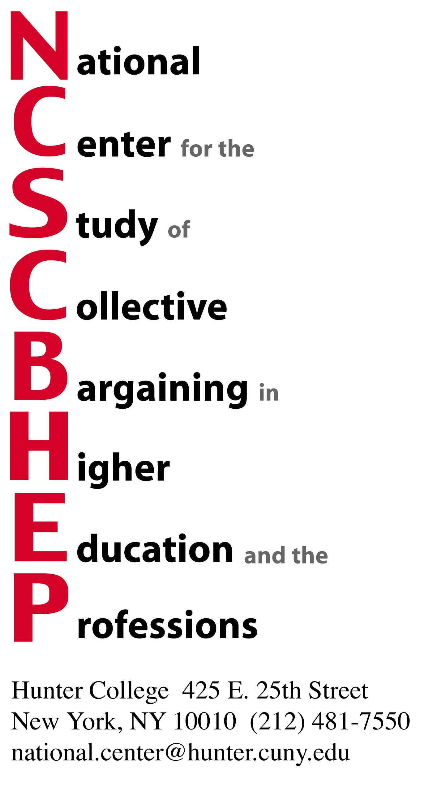

Dear Colleagues and Friends of the National Center,

We are pleased to inform you that the preliminary program of the 36th Annual Conference, Academic Bargaining in an Era of Constraint, is now posted on our website: www.hunter.cuny.edu/ncscbhep. We will update the program on our website as panelists accept our invitations.

If you want to reserve your place now please e-mail the National Center at national.center@hunter.cuny.edu or by calling our offices at 212.481.7550. The registration form is also posted on our website.

This year we have again reserved room blocs at the Affinia Dumont and at the Affinia Shelburne Murray Hill (which has been completely renovated).

Internet Reservations:

- Go to www.affinia.com
- Choose Location/Hotel
- Choose the number of Adults and Children
- Go to April 2009 on the calendar
- Click only on the day/night that will begin the reservation
- Then click the number of Nights
- Put in one of the following Group Codes in the bar at the bottom right of the calendar:
Affinia Dumont. group code NATDU
Affinia Shelburne Murray Hill. group code NATSH
(if any errors occur between steps 4-7 exit out of the website and re-do the
procedure, room rate is $279.00/night)
- Click on Check Availability, do not press Enter

E-mail Reservations:
reservations@affinia.com, mention the group name: National Center for the Study of Collective Bargaining, and indicate either the Affinia Dumont or the Affinia Shelburne Murray Hill

Phone Reservations:
1-866-233-4642 and mention the group name: National Center for the Study of Collective Bargaining, and indicate either the Affinia Dumont or the Affinia Shelburne Murray Hill

We urge you to book your rooms early.

We are holding the line on all prices (conference fees and hotel rate). The Sunday evening buffet and breakfasts and lunches on Monday and Tuesday (all included in the conference fee) will help keep your costs down in these tough times.

We look forward to seeing you in New York.

Sincerely,

Dr. Richard Boris
Executive Director

