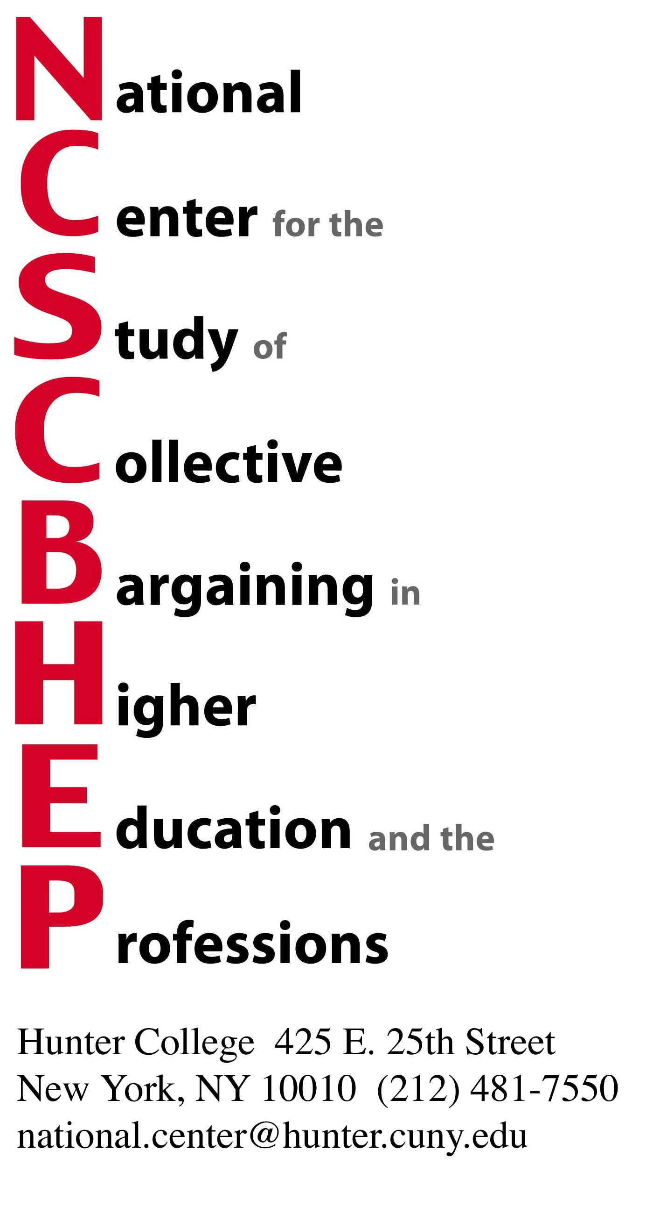

36th National Conference: Academic Bargaining in An Era of Constraint

April 19, 20, 21, 2009

REGISTRATION FORM (two pages)

The printed program brochure along with a registration form will be surface mailed in January. For those of you who wish to enroll early please use the form below:

Please reserve _________________ place(s) at the 35th Annual Conference on Collective Bargaining

_________________@ membership rate $385.00 (one attendee and subscription to all National Center publications)

_________________@ additional conference registration rate $230.00 (after payment of membership rate)

_________________@ non-member conference registration rate $345.00

_________________@ special rates for graduate employees, contingent faculty, and postdoctorates (please contact the National Center)

NAME: __________________________________

TITLE: __________________________________

INSTITUTION: ____________________________

ADDRESS: _______________________________

E-MAIL: _________________________________

PHONE:__________________________________

ADDITIONAL PARTICIPANTS (please complete for each registrant):

NAME: __________________________________

TITLE: __________________________________

INSTITUTION: ____________________________

ADDRESS: _______________________________

E-MAIL: _________________________________

PHONE:__________________________________

Make checks payable to:

NCSCBHEP – Hunter College

Mail to:
NCSCBHEP
Hunter College
425 E. 25th Street– Box 615
New York, New York 10010

or

E-mail to: national.center@hunter.cuny.edu

Thank you!

