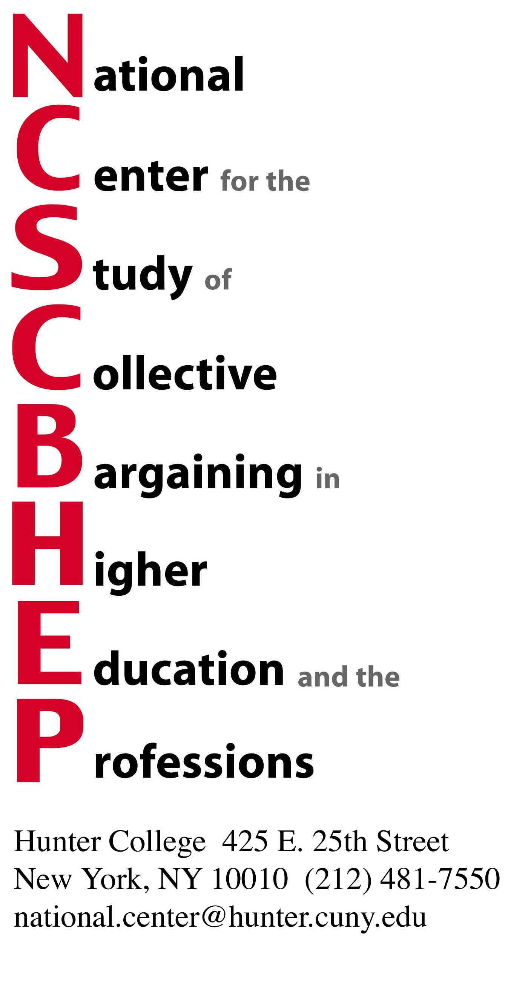

38th National Conference
Together at the Table: Moving the Academy Forward through Collective Bargaining
April 10, 11, 12, 2011

REGISTRATION FORM (two pages)

The printed program brochure along with a registration form will be surface mailed in January. For those of you who wish to enroll early please use the form below:

If you paid by credit card please check here O

Please reserve _________________ place(s) at the 38th Annual Conference on Collective Bargaining

_________________@ membership rate $385.00 (includes one conference registration,
subscription to the 2006 Directory of Faculty Contracts, and 2011 edition upon completion)

_________________@ additional conference registration rate $230.00 (after payment of membership rate)

_________________@ non-member conference registration rate $345.00

_________________@ special rates for graduate employees, contingent faculty, and postdoctorates (please contact the National Center)

NAME: __________________________________

TITLE: __________________________________

INSTITUTION: ____________________________

ADDRESS: _______________________________

E-MAIL: _________________________________

PHONE:__________________________________

ADDITIONAL PARTICIPANTS (please complete for each registrant; create a separate sheet if needed):

NAME: __________________________________

TITLE: __________________________________

INSTITUTION: ____________________________

ADDRESS: _______________________________

E-MAIL: _________________________________

PHONE:__________________________________

Make checks payable to:

NCSCBHEP – Hunter College

Mail to:
NCSCBHEP
Hunter College
425 E. 25th Street– Box 615
New York, New York 10010

For Credit Card Payment: go to www.hunter.cuny.edu/ncscbhep then click on Moving the Academy Forward through Collective Bargaining; finally click on Credit Card Payment

Thank you!

