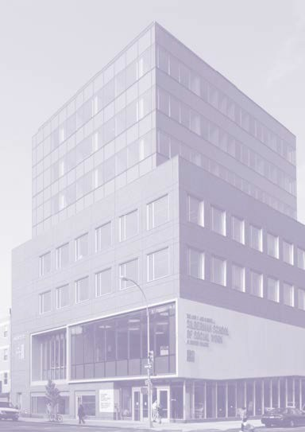
BECOMING A DIETITIAN

To become an RDN, students must complete the following:
- A minimum of a Bachelor’s degree or equivalent,
- Didactic and supervised practice programs, or a program integrating both components such as the Hunter College IPND, accredited by the Accreditation Council for Education in Nutrition and Dietetics (ACEND) of the Academy of Nutrition and Dietetics (AND);
- Pass the Registration Examination for Registered Dietitians administered by the Commission on Dietetic Registrations (CDR) for U.S. national credentialing.

CAREER OPPORTUNITIES

Graduates of Hunter’s IPND program typically pursue:

  - Registered Dietitian Nutritionist Credential
  - Specialized credentials in nutrition
  - PhD in Nutrition or Public Health

And find successful employment in:

  - Public and private hospitals
  - Community health centers
  - Public health programs
  - Food service management
  - Long-term care facilities
  - Nutrition entrepreneurship
  - Higher education

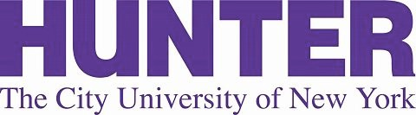
24-month full time or 36 months part-time
53 credits and 1050 supervised hours

Attendance at an Information Session is strongly encouraged. Sign up at our webpage.

For further information about the Hunter College Integrated Program in Nutrition and Dietetics, visit:

www.hunter.cuny.edu/nutrition/graduate

CONTACT INFORMATION
Khursheed Navder, PhD, RDN, FAND Director, Integrated Program in Nutrition and Dietetics
Hunter College School of
Urban Public Health
2180 Third Avenue (@ 119th St.) New York, NY 10035
212-396-7776
khursheed.navder@hunter.cuny.edu

Accreditation: Hunter’s IPND program curriculum meets the program requirements established by the Accreditation Council for Education in Nutrition and Dietetics (ACEND) of the Academy of Nutrition and Dietetics (AND), and upon completion, students become eligible for the Registered Dietitian Nutritionist (RD/RDN) credential. More on AND at www.eatright.org and www.cdrnet.org .
INTEGRATED
PROGRAM IN NUTRITION AND
DIETETICS
SCHOOL OF URBAN PUBLIC HEALTH

PROGRAM DESCRIPTION
PREREQUISITE COURSES
APPLICATION DEADLINE

The Hunter Integrated Program in Nutrition and Dietetics combines the graduate-level didactic and supervised practice programs that afford graduates the eligibility to take the Registration Examination for Registered Dietitians, and to apply for active membership in the Academy of Nutrition and Dietetics.

The IPND is a 53-credit, 1050 hour Master’s Degree program taken over 24 months full-time or 36 months part-time. The program accepts approximately
30-35 students each year. Graduates receive a Verification Statement granting eligibility for the Registration Examination for Registered Dietitians.
- General Chemistry (with lab)
- Organic Chemistry (with lab)
- Anatomy and Physiology I & II (both with lab)
- Biochemistry
- Microbiology
- Intro to Nutrition
- Intro to Food Science
- Statistics
- Social Science
Submit all application materials to Hunter Graduate Admissions:

March 1
- Non US-institution: February 1
- Students are accepted once per year for the fall semester.
- Please see website for required materials

MISSION STATEMENT
The mission of the Integrated Program in
 | Courses | Seminar | Rotation | Credits
Fall 1 | Biostatistics 3 cr  Food Service & Management 3 cr  Community Nutrition Education 3 cr  Advanced Nutrition I 3 cr  Clinical Nutrition I 3 cr | NUTR 700 3 cr | Community Nutrition  100 hours | 15
Winter 1 |  |  | Food Service Management  200 hours | 0
Spring 1 | Nutrition Research 3 cr  Advanced Nutrition II 3 cr  Clinical Nutrition II 3 cr  Food Science & Environment Lec 3 cr  Food Science & Environment Lab 1cr | NUTR 702 3 cr |  | 16
Summer 1 |  |  | Focused Nutrition Practice  300 hours | 0
Fall 2 | Nutrition & Disease 3 cr  Adv Nutrition & Asmt Lab 1 cr  Nutrition Asmt & Counseling 3 cr | NUTR 701 3 cr |  | 10
Winter 2 |  |  | Clinical  400-450 hours | 0
Spring 2 | Nutrition & Human Development 3 cr  Capstone 3 cr | NUTR 703 3 cr |  | 9

Nutrition and Dietetics is to prepare Registered Dietitian Nutritionists with increased competence and advanced skills in community and clinical nutrition, and to advance the science and practice of nutrition and dietetics.

WE VALUE:
  - DIVERSITY
  - LIFE-LONG LEARNING
  - AN INTERDISCIPLINARY APPROACH TO HEALTHCARE
  - SOCIALLY AND ECOLOGICALLY SUSTAINABLE FOOD SYSTEMS

