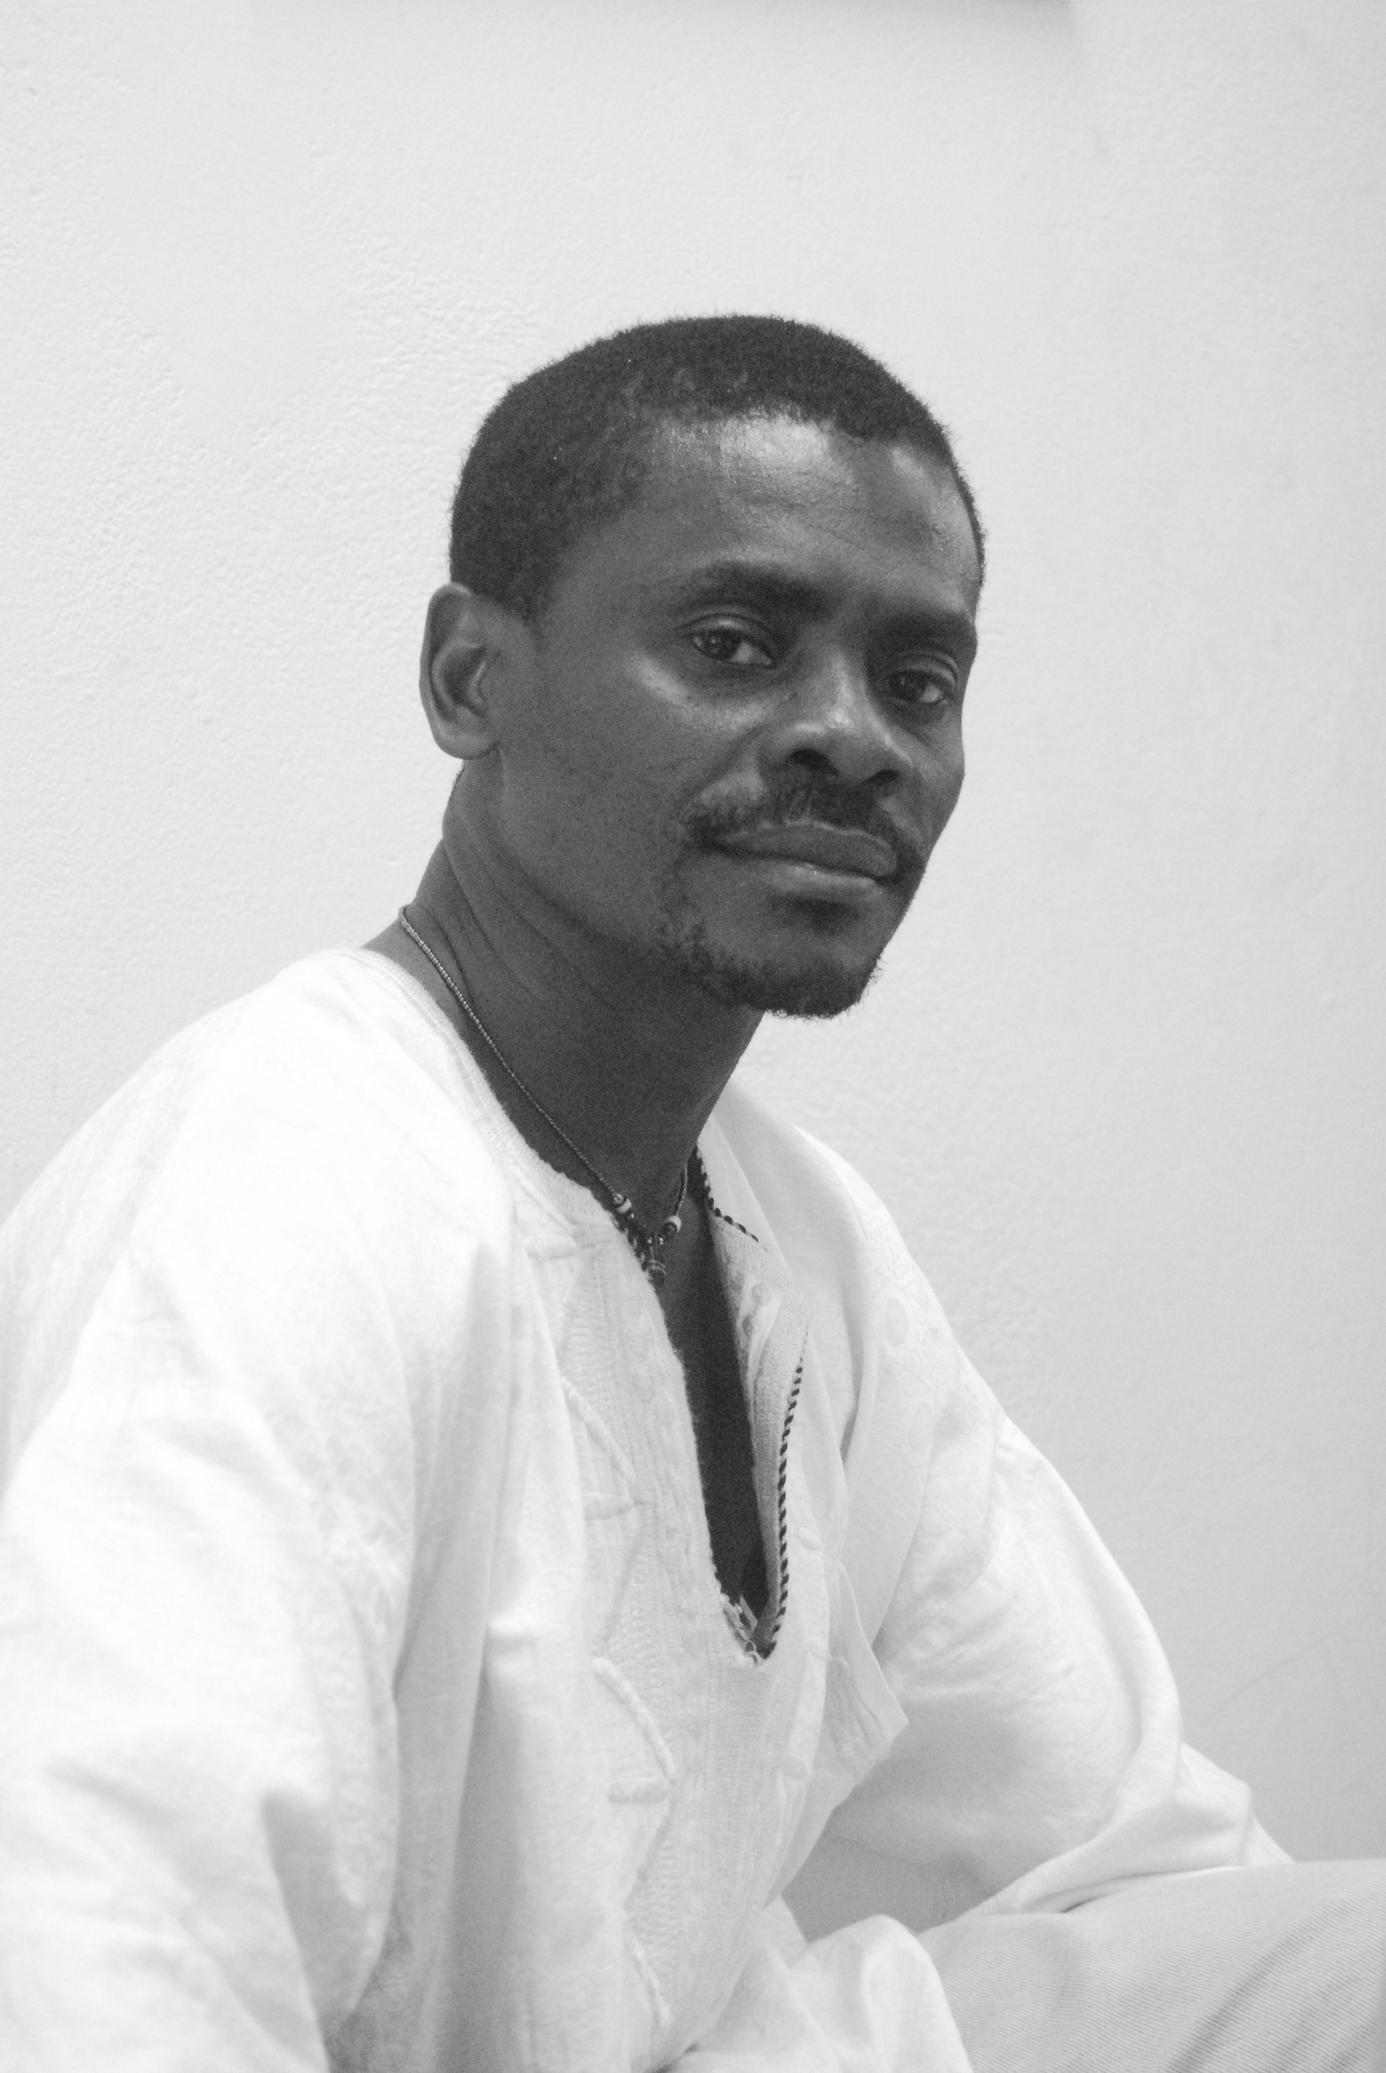
The Romance Languages Department at Hunter College
invites you to a lecture (in Spanish) by the renowned African writer and intellectual

Juan Tomás Ávila Laurel

Literature in Equatorial Guinea in the time of the Oil Boom

Tuesday, Feb. 9

2:10-3:30 p.m.

ROOM 707C

From Equatorial Guinea (West Africa)—a native of the island of Annobón, now living in Malabo—Juan Tomás Ávila Laurel is an immensely prolific writer and one of the most internationally celebrated. Ávila Laurel is author of more than a dozen books, including novels, plays, poetry, essays, and film scripts, in addition to several unpublished manuscripts. Among his published titles are: Poemas [Poems, 1994]; Los hombres domésticos [Domestic Men, 1994]; Historia íntima de la humanidad [Intimate History of Humanity, 1999]; the novel La carga [The Burden, 1999]; Awala cu sangui [Awala with Blood, 2000]; El derecho de pernada, o de cómo se vive el feudalismo en el siglo XXI [‘First Night’, or How Feudalism Survives into the XXI Century, 2000]; the novel El Desmayo De Judas [Judas’ Faints, 2001]; Nadie tiene buena fama en este país [Nobody Has A Good Name in this Country, 2002]; El fracaso de las sombras [The Failure of the Shadows, 2004]; Cómo convertir este país en un paraíso, con otras reflexiones sobre Guinea Ecuatorial; Guinea Ecuatorial. Vísceras [Equatorial Guinea. Entrails, 2006]; Cuentos Crudos [Plane for the Rich, Thief of Pigs, 2008], and Arde el monte de noche [The Forest Burns at Night, 2009]. He has been director of the literary journal El patio, and is currently director of Atanga, the only literary and cultural journal published in Equatorial Guinea. For questions, please send an e-mail to mhern@hunter.cuny.edu

